Department of Families, Seniors, Disability Services and Child Safety
Restrictive Practice Compliance Report

Reporting Compliance

Organisations are required to report the use of any Restrictive Practices which have occurred
during the month, to the Department. The reporting of usage can occur any time during the month, or once the end of the month has been reached.

Once the data entry of the Restrictive Practice Usage information has occurred for a Service User and Service Outlet, this information is to be “authorised”. The authorisation is a confirmation step and indicates that the Restrictive Practice Usage submission is complete for a Service Outlet,
Service User and reporting month.
This authorisation step is needed to:
- Identify whether all usage been reported for a Service User and Service Outlet for the month.
- Differentiate between a Service User with no Restrictive Practice Usage in the month vs unknown usage due to non-reporting.
Authorisation is required in the following scenarios;
- The Service User has an approval in place for the use of restrictive practices, and
  - Restrictive practices have been used, or
  - Restrictive practices have not been used; or
- The Service User does not have an approval in place, and
  - Restrictive practices have been used.
The process of Authorising is to be undertaken by an Officer with the access of Authorising Agency Officer role for that Organisation.

Refer to the Restrictive Practice Authorisation Guide for more information on this process.

Monthly Reporting Timeline
The relevant Service Provider must give the information to the Chief Executive—
- by the second Friday of the calendar month immediately after the calendar month in which the restrictive practice is used; and
- at other times if the Chief Executive, by written notice, requires the relevant service provider to do so.

Compliance Report
The Restrictive Practice Compliance Report is provided to allow Organisations the ability to
monitor their own compliance around the reporting and recording of usage of restrictive practices.

Display Restrictive Practice Compliance Report
From the Online Date Collection page:
- Select Reports hyperlink from the Main Menu to display the Reports page.
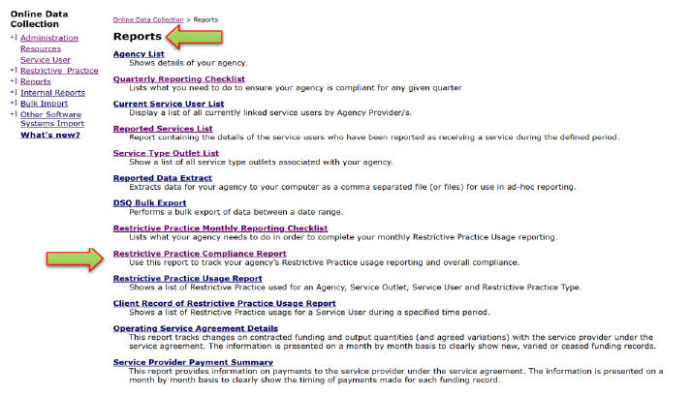
- Select the Restrictive Practice Compliance Report hyperlink from the Reports Menu, to display the Compliance Report page.
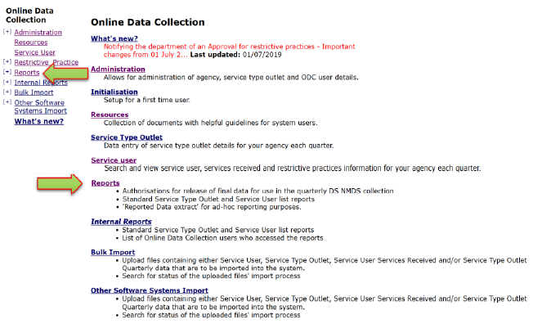
- Restrictive Practice Compliance Report fields are displayed
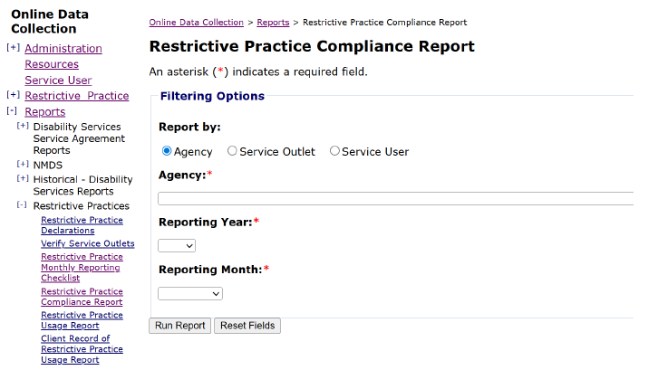

- In order to ascertain the Agency’s compliance position, select ‘Agency’; or
- In order to ascertain a specific Service Outlet within the Agency, select ‘Service Outlet’; or
- In order to ascertain the compliance status for a specific Service User, select ‘Service User’.
Based on the securities within ODC, the Agency field will be pre-populated.
- Select the Reporting Year from the drop-down list.
- Select an individual Reporting Month or select ‘All’ to view the compliance report for a complete year.
- Click “Run Report”.
The resulting Restrictive Practice Compliance Report can be accessed by clicking on the Link: Restrictive Practice Compliance Report.
- The Restrictive Practice Compliance Report will open as a ‘preview’ in your browser.
- By clicking on the ‘Export drop down menu’ icon, you can save the report as a PDF or export it to MS Excel for graphing etc.

Understanding the Restrictive Practice Compliance Report
Month – Year – The Month and Year for which the data in the line relates.
Service Outlet Reference – The Service Outlet reference number.
Service Outlet – The name of the Service Outlet where the approval has been provided or where instances of use of restrictive practices has been reported.
Client Reference – The (departmental) unique identifier for the client.
RP Approval – During the Month and Year on this line, is / was there an approval for the use of restrictive practices in place? The values for this field are;
Yes – an approval is / was in place for the whole month / year
No – there is / was no approval in place for the whole month / year
Partial – there is / was an approval in place for part of the month / year
Approval End Date –The end date of the approval for the use of Restrictive Practices.
Reporting Status – The reporting status on the use of restrictive practice for this client for the month / year. Reporting Status values for this field are;
Not Reported – Where there is an approval in place (for the whole month or partial period of it)
but NO instances of use have been recorded in the system (ODC)
Draft – Regardless of any approval which may or may not be in place for the month / year, client and Service Outlet, instances of use of restrictive practices have been recorded in the
system but are yet to be Authorised (confirmed) as being true and correct.
Reported – Regardless of any approval which may or may not be in place for the month / year, client and Service Outlet, instances of use of restrictive practices have been recorded
in the system and have been Authorised (confirmed) as true and correct.
Last Reported Usage Date –The last date that restrictive practice usage was recorded for the combination of month / year, Service Outlet, and Client.
Authorised Date – The date the recorded usage was authorised. This will be blank if the authorising stage has not been completed.
Reporting Compliance – A Yes / No value to indicate if Reporting Compliance has been met in accordance with the legislated timeframes.
Indemnity Date – In accordance with section 169 (3) (b), of the Disability Services Act 2006, the relevant service provider may only use the restrictive practice until 30 days after the existing consent ends. The Indemnity Date field is the date as at the 30th day.
Number of Days Outside Indemnity – A system calculated field returning the number of days between the Last Reported Usage Date and the Indemnity Date.
Overall Compliance – A Yes / No value to indicate if Overall Compliance has been met. Overall compliance is achieved when Reporting Compliance is met, and there is a current approval for the
use of restrictive practices in place, for the Service User and Service Outlet.
For further clarification of this report, please contact Compliance and Reporting, Restrictive Practice Operations on 1800 902 006 (option 1) or at compliance_rp@qld.gov.au.

