Department of Families, Seniors, Disability Services and Child Safety

User Guide - Reporting Restrictive Practice Information using Online Data Collection (ODC)

Guide to Key Links in ODC to Record Restrictive Practice Usage.
This is a guide to common operations in ODC for recording Restrictive Practice Usage. More detailed information about recording Restrictive Practice Usage for a particular Restrictive Practice Type can be obtained from the relevant Factsheets on Recording Restrictive Practice Usage in ODC.

Table of Contents

1. About this Package 5
Help Available 5
Notify the Department of Changes to the Service User Details 5
Monthly Reporting Timeline 5
2. Types of Access 6
System Administrator 6
Authorising Agency Officer 6
Data Entry Operator 6
3. Types of Restrictive Practice usage Reporting 7
4. Main Menu 8
Service User 8
Reports 8
Bulk Import 8
5. Summary of Steps for Manual Data Entry 9
6. Search a Service User and Display Service User Details 10
Search Service User 10
View Service User 11
Service User Details 11
Display Restrictive Practice Summary 12
Adding New Restrictive Practice Usage for a Service User 12
Adding Usage to an Existing Restrictive Practice Type for a Service User 13
7. Episodic Restrictive Practice – Add a New Restrictive Practice Type 14
Chemical Restraint as Required 15
Containment 18
Mechanical Restraint 19
Physical Restraint 20
Restricted Access to Objects (RATO) 21
Seclusion 22
8. Episodic Restrictive Practice - Add Usage to An Existing Restrictive Practice Type 23
9. Routine Restrictive Practice – Add a New Restrictive Practice Type 27
Chemical Restraint Fixed Dose 28
Containment 30
Mechanical Restraint 31
Restricted Access to Objects 32
10. Routine Restrictive Practice - Add usage to an existing Restrictive Practice Type 33
11. Housekeeping Tips 36
Service User Does Not Have Restrictive Practice Approval 36
Monthly Summary 37
Expire and Un-Expire a Restrictive Practice Type 37
Delete Restrictive Practice Usage 38
Authorisation 38
12. Reports 39
Restrictive Practice Monthly Checklist 39
Client Record of Restrictive Practice Usage Report 39
Restrictive Practice Usage Report 39
Compliance Report 39
Bulk Import 40

About this Package
This package has been designed to assist Service Providers who are reporting using ODC to collect Restrictive Practice information. It summarises the key links a Service Provider will need to access to input their data, and it can be used as a reminder each month.

Help Available
Publications and Resources:
Resources | Department of Families, Seniors, Disability Services and Child Safety OR Online Data Collection Help
Email help: enquiries_rp@qld.gov.au
Phone help: 1800 902 006 - Calls from mobile phones are charged at applicable rates.

Notify the Department of Changes to the Service User Details
Email: compliance_rp@qld.gov.au

Monthly Reporting Timeline
The relevant Service Provider must give the information to the Chief Executive—
- by the second Friday of the calendar month immediately after the calendar month in which the restrictive practice is used; and
- at other times if the Chief Executive, by written notice, requires the relevant service provider to do so.

Types of Access

System Administrator
- Can add, edit or delete ODC system users for Restrictive Practice for their own organisation.
- Allocate roles and Service Outlets and Service Type Outlets to user accounts.
- Can run Restrictive Practice Monthly Reporting Checklist, Restrictive Practice Compliance Report, Restrictive Practice Usage Report and Client Record of Restrictive Practice Usage Report.
- Can submit requests to the Department for changes to existing Service Users, Service outlet and Service Type Outlet information.

Authorising Agency Officer
- Can add, edit or delete Restrictive Practice usage information.
- Can authorise Restrictive Practice Monthly Data.
- Can upload Restrictive Practice files and search Import Status.
- Can run Restrictive Practice Monthly Reporting Checklist, Restrictive Practice Compliance Report, Restrictive Practice Usage Report and Client Record of Restrictive Practice Usage Report.
- Can submit requests to the Department for changes to existing Service Users, Service outlet and Service Type Outlet information.

Data Entry Operator
- Can add, edit or delete Restrictive Practice Usage information.
- Can run Restrictive Practice Monthly Reporting Checklist, Restrictive Practice Compliance Report, Restrictive Practice Usage Report and Client Record of Restrictive Practice Usage Report.
- Can submit requests to the Department for changes to existing Service Users, Service outlet and Service Type Outlet information.

Types of Restrictive Practice usage Reporting
ODC allows for two types of Restrictive Practice usage reporting for a Service User.
- Episodic Restrictive Practice Usage.
- Routine Restrictive Practice Usage.
Episodic Restrictive Practice usage refers to each instance of use of Restrictive Practice which is used in response to behaviour that causes harm to self or others. Usage is reported for each instance of Restrictive Practice used, i.e. on date x, Restrictive practice y was used.
Routine Restrictive Practice refers to Restrictive Practice usage, which is consistently used or applied each day, for example, medications given each day (chemical restraint) or headgear worn during awake hours (mechanical restraint).
- At the commencement of the use through to the end of use for the month.
- From start of reporting month to end of reporting month if used each and every day.
- For part of the month due to Service User transitioning in and out of care.
- Change of circumstances.
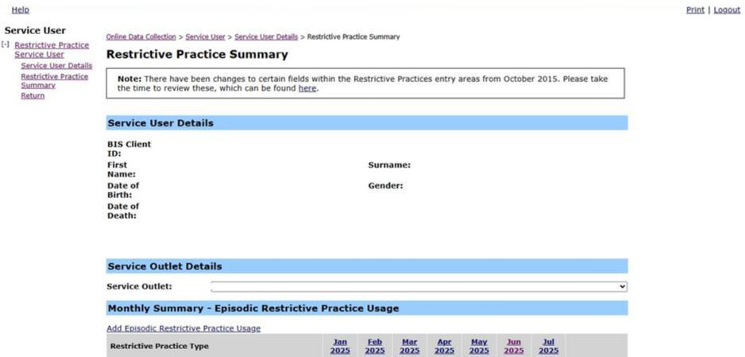

Example of a Service User’s Restrictive Practice Summary page detailing Episodic and Routine Usage.

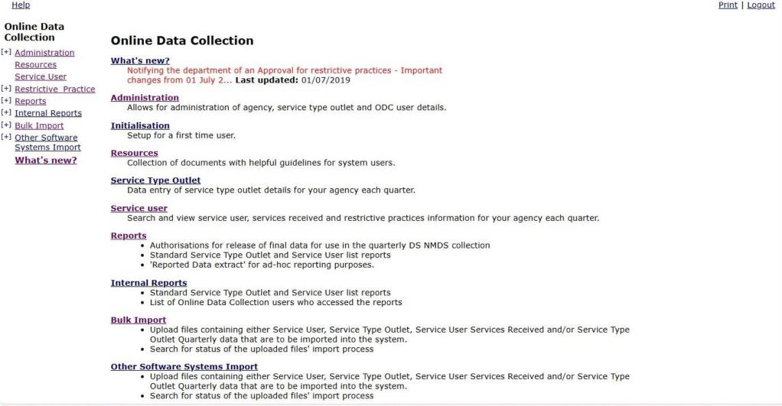
Main Menu
On the main menu on the Online Data Collection page the three sub-menus utilised for Restrictive Practice information are:

Service User
- Search and view Service User.
- Record and view Restrictive Practice information for a Service User.

Reports
- Authorisation for release of final data for use in the monthly Restrictive Practice collection.
- Links for:
  - Restrictive Practice Monthly Reporting Checklist;
  - Restrictive Practice Compliance Report;
  - Restrictive Practice Usage Report;
  - Client Record of Restrictive Practice Usage Report.

Bulk Import
- Upload files containing Service User’s Restrictive Practice Usage for import into ODC. Organisations with a large number of clients may use the Bulk Import functionality to assist in the data entry of Restrictive Practice Usage information.
- Search the status of an uploaded file.

Summary of Steps for Manual Data Entry
Step | Topic | Reference
 | Search a Service User. | Step 1  Page 9
 | Display Service Users Details. | Step 4  Page 10
 | Selecting the Restrictive Practice Summary hyperlink to display the summary screen. | Page 11
 | If reporting Episodic Restrictive Practice Type:  - New Restrictive Practice Usage  - Existing Restrictive Practice Usage | Page 13  Page 22
 | If reporting Routine Restrictive Practice Type:  - New Restrictive Practice Usage  - Existing Restrictive Practice Usage | Page 26  Page 32
 | Select add Usage and enter details for Usage and Save. | Page 23
 | Repeat step 6 until all Usage for the Restrictive Practice Type has been entered for the Service User and Service Outlet for the month. | Page 23
 | Return to Step 4 and repeat Steps 4 to 7 to add Usage for any other Types of Episodic Restrictive Practice used in the month. | Page 23  Page 24
 | Return to Step 5 and repeat Steps 5 to 7 to add Usage for any other Types of Routine Restrictive Practice used in the month. | Page 23  Page 24
 | Return to Step 1 and repeat Steps for next Service User. | Page 9
 | Review Restrictive Practice Monthly Checklist to ensure reporting for all Service Outlets is complete. | Page 34
 | Authorise Restrictive Practice reporting when all the data entries have been made. This is required to be completed by the Authorising Agency Officer. | Page 36

Search a Service User and Display Service User Details

Search Service User
From the Online Data Collection page:
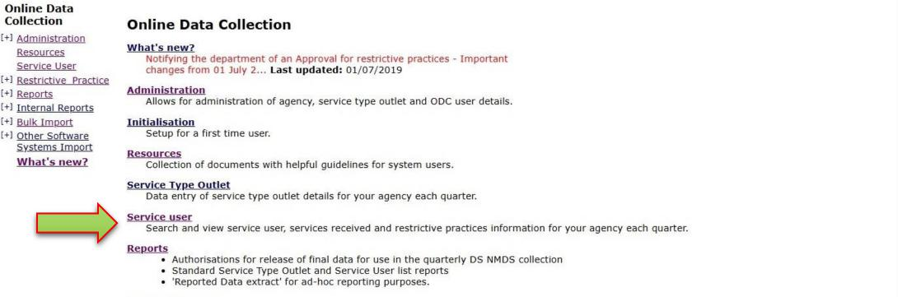
- Select Service User
Displays the Search Service User page.
- Enter Service User’s last name in the Surname field OR enter Service User’s first name in the First Name field OR enter Service User’s BIS reference number in the BIS Client Id field.
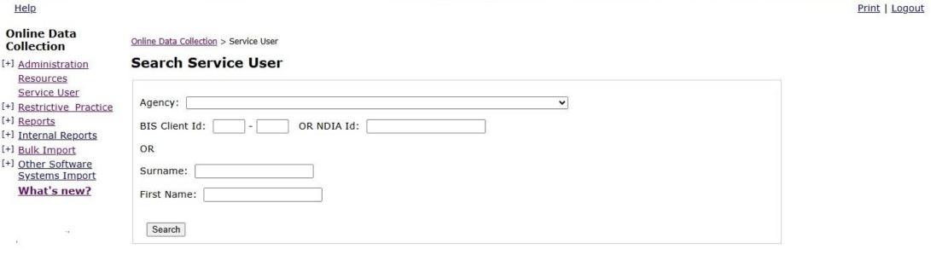
- Press ‘Search’ button. Displays the Search Service User page with a search result.
Tip:
- At least one search field must be entered.
- Enter two or three consecutive characters in the Surname field. The result returned will display service users with the characters in that sequence anywhere in the surname. The same can be done in the First Name field.

View Service User
With the Search Service User search result on the screen:
- Select the Service User’s surname hyperlink. Displays the Service User Details page.
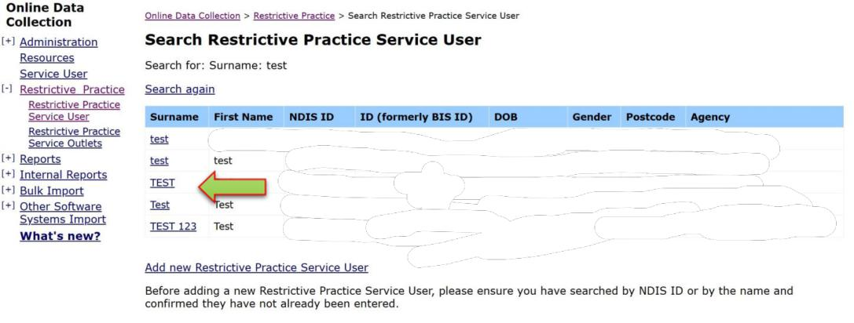
Tip:
- Another search can be actioned by selecting the Search again hyperlink.
- Return to the Main Menu by selecting Online Data Collection hyperlink.

Service User Details
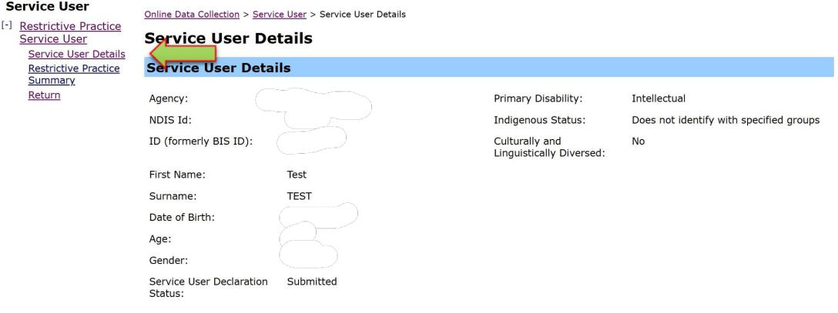
The Service User Details page lists a Service User menu (on the left side) with a hyperlink to Restrictive Practice Summary.

Display Restrictive Practice Summary
Selecting the Restrictive Practice Summary hyperlink on the Service User Details page displays the Restrictive Practice Summary page. Episodic and Routine Restrictive Practice Usage can be recorded from this page. If no previous Usage has been recorded, the Monthly Summary for Episodic Restrictive Practice Usage or Routine Restrictive Practice Usage displays No records found.

Adding New Restrictive Practice Usage for a Service User
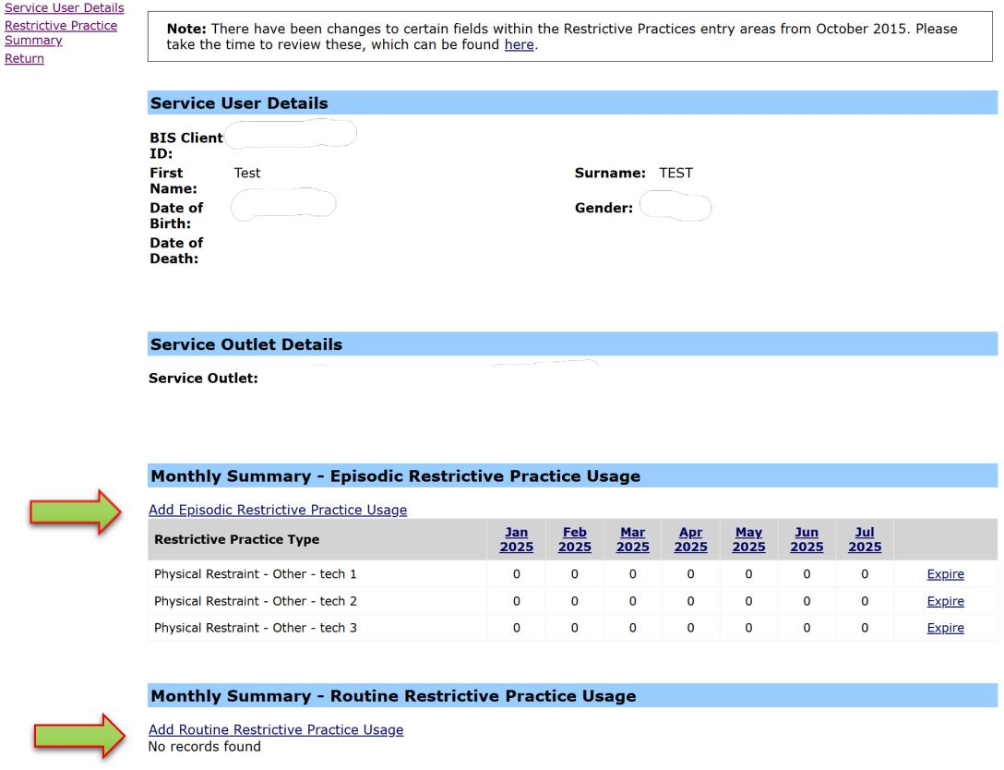
When recording the first:
- Episodic Restrictive Practice Usage go to Episodic Restrictive Practice – Add a New Restrictive Practice Type on page 13.
- Routine Restrictive Practice Usage go to Routine Restrictive Practice – Add a New Restrictive Practice Type on page 27.

Adding Usage to an Existing Restrictive Practice Type for a Service User
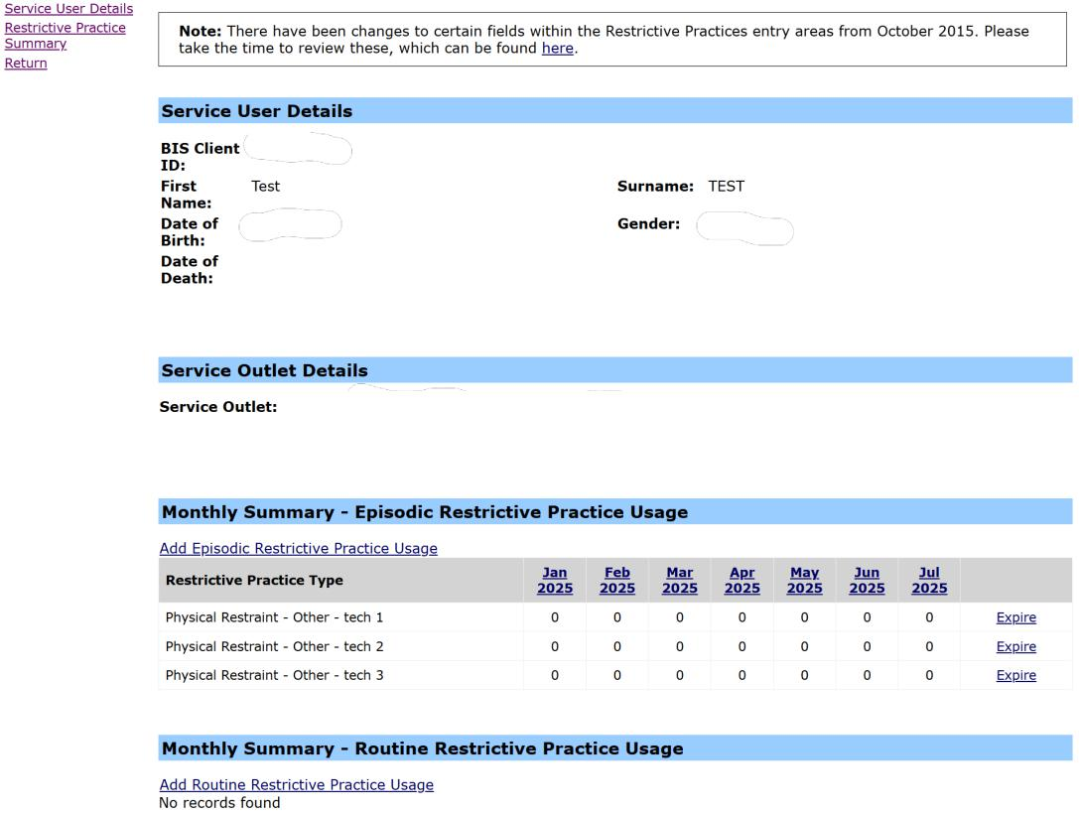
Restrictive Practice Usage previously recorded displays under the “Monthly Summary for Episodic Restrictive Practice Usage” or “Monthly Summary for Routine Restrictive Practice Usage”.
If Usage has previously been recorded the options available are:
- Add Usage to a new Episodic Restrictive Practice Type go to Episodic Restrictive Practice – Add a New Restrictive Practice Type on page 13.
- Add Usage to an existing Episodic Restrictive Practice Type go to: Episodic Restrictive Practice - Add Usage To An Existing Restrictive Practice Type on page 22.
- Add Usage to a new Routine Restrictive Practice Type go to: Routine Restrictive Practice – Add a New Restrictive Practice Type on page 26.
- Add Usage to an existing Routine Restrictive Practice Type go to: Routine Restrictive Practice - Add Usage To An Existing Restrictive Practice Type on page 32.

Episodic Restrictive Practice – Add a New Restrictive Practice Type
With the Restrictive Practice Summary page on display for the Service User:
- Select the Service Outlet where the Restrictive Practice usage occurred
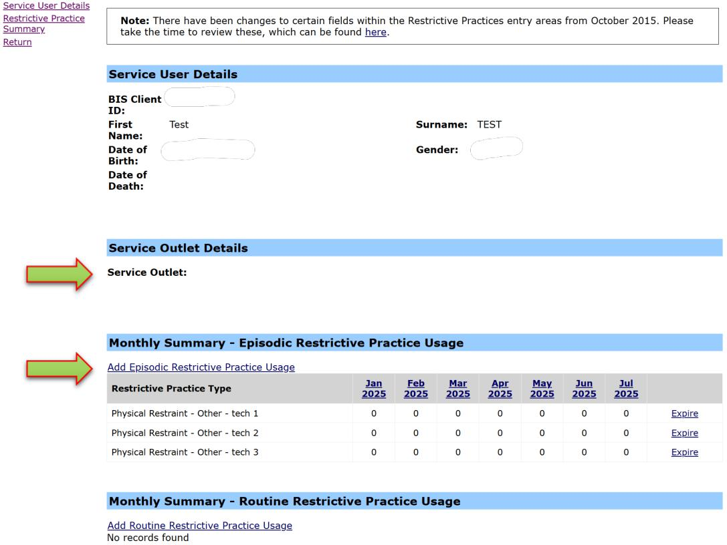
- Select the Add Episodic Restrictive Practice Usage hyperlink, to display the Add Episodic Restrictive Practice Usage page.
Note: If no Episodic Usage has been entered for the Service User, the only option is to add a new Restrictive Practice Type.

Chemical Restraint as Required
- Select the drop-down list for Add a new Restrictive Practice type.
- The list displays the Restrictive Practice types:
- Chemical Restraint as Required
- Containment
- Mechanical Restraint
- Physical Restraint
- Restricted Access to Objects
- Seclusion
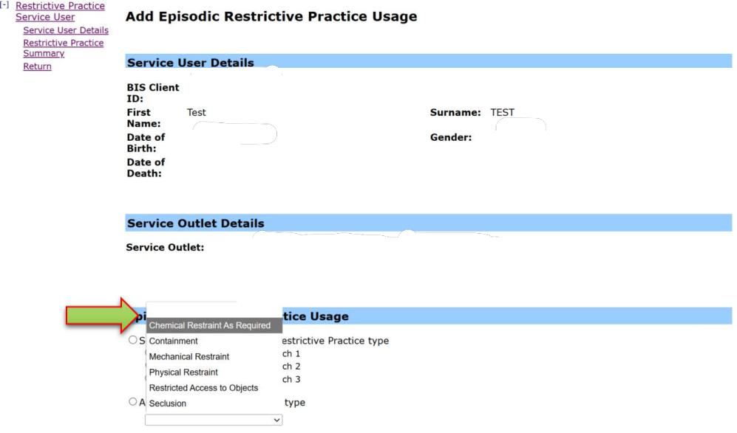
- Select the Restrictive Practice type.

Note: In this example Chemical Restraint as Required is selected, the details will change for each different Restrictive Practice Type. Refer to pages 17 to 21 for details.
- Enter the following information:
- Medication
- Medication Amount
- Prescribed by
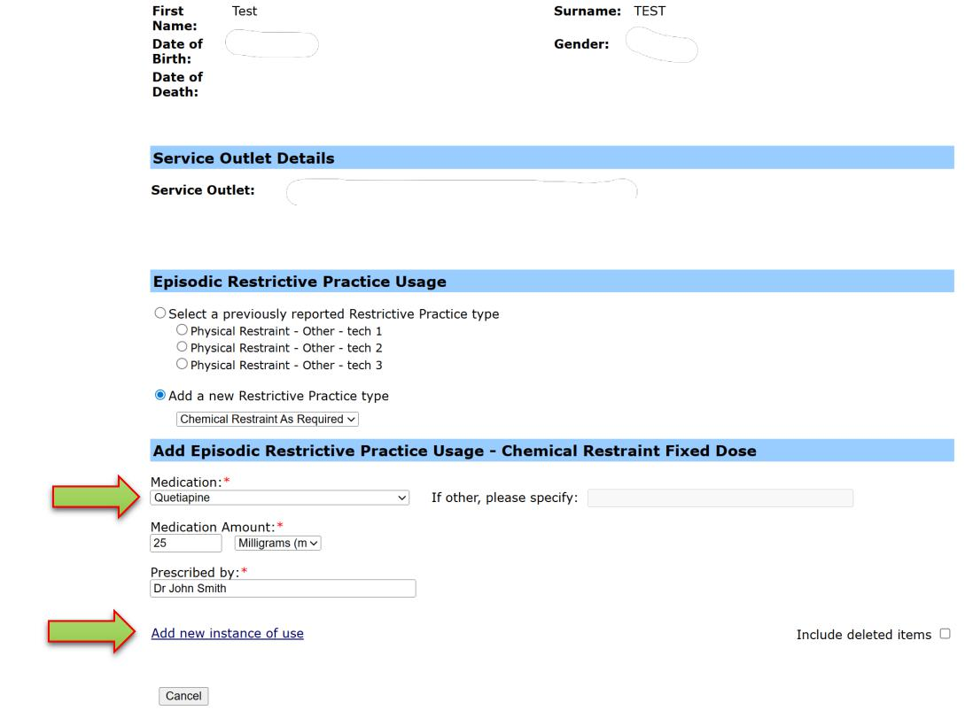
- Select Add new instance of use hyperlink.

- Enter the following information:
- Date
- Time
- Select from the drop down list the following information:
- Primary Behaviour Posing Risk to Harm to Self or Others
- Injury – only if the use of the restrictive practice resulted in an injury, not the behaviour of concern
- Select Save.
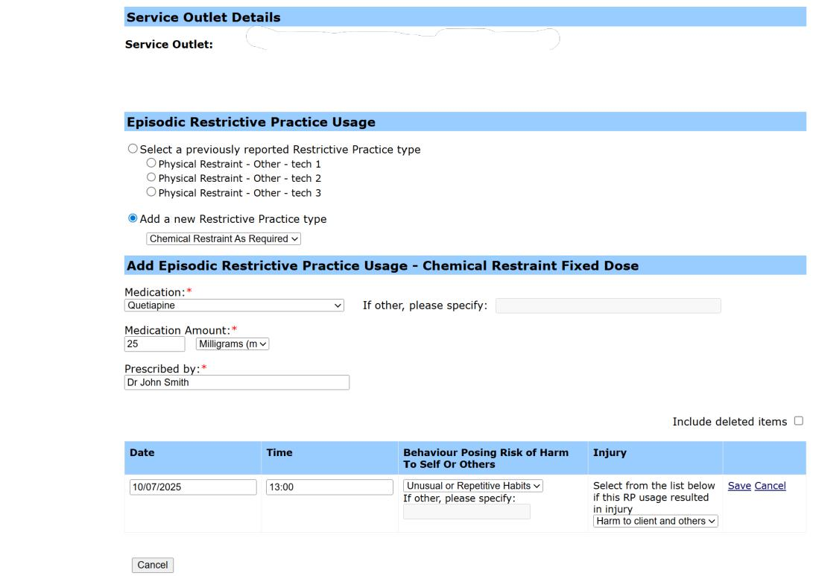
Upon saving, the user may continue to add instances of use to the Restrictive Practice Type by selecting the Add new instance of use hyperlink. Alternatively, select the ‘Cancel’ button to return to the Restrictive Practice Summary page for the Service User.
Tip:
- Dates can be entered in the format dd/mm/yy
- Start Time is entered in the following format hhmm (note there is no “:”)
- End Time is entered in the following format hhmm (note there is no “:”)

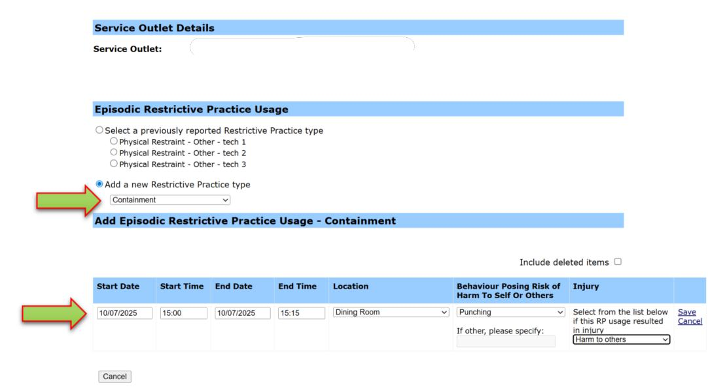
Containment
The information captured for Episodic Restrictive Practice Usage for Containment includes:
- Start Date
- Start Time
- End Date
- End Time
- Location
- Primary Behaviour Posing Risk to Harm to Self Or Others
- Injury – only if the use of the restrictive practice resulted in an injury, not the behaviour of concern

Mechanical Restraint
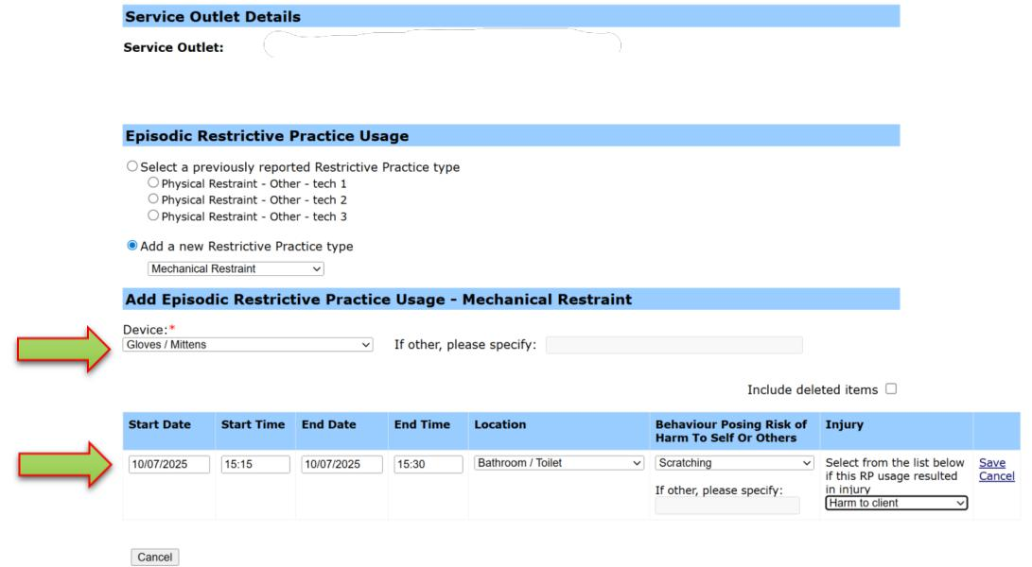
The information captured for Episodic Restrictive Practice Usage for Mechanical Restraint includes:
- Device
- Start Date
- Start Time
- End Date
- End Time
- Location
- Primary Behaviour Posing Risk to Harm To Self Or Others
- Injury – only if the use of the restrictive practice resulted in an injury, not the behaviour of concern

Physical Restraint
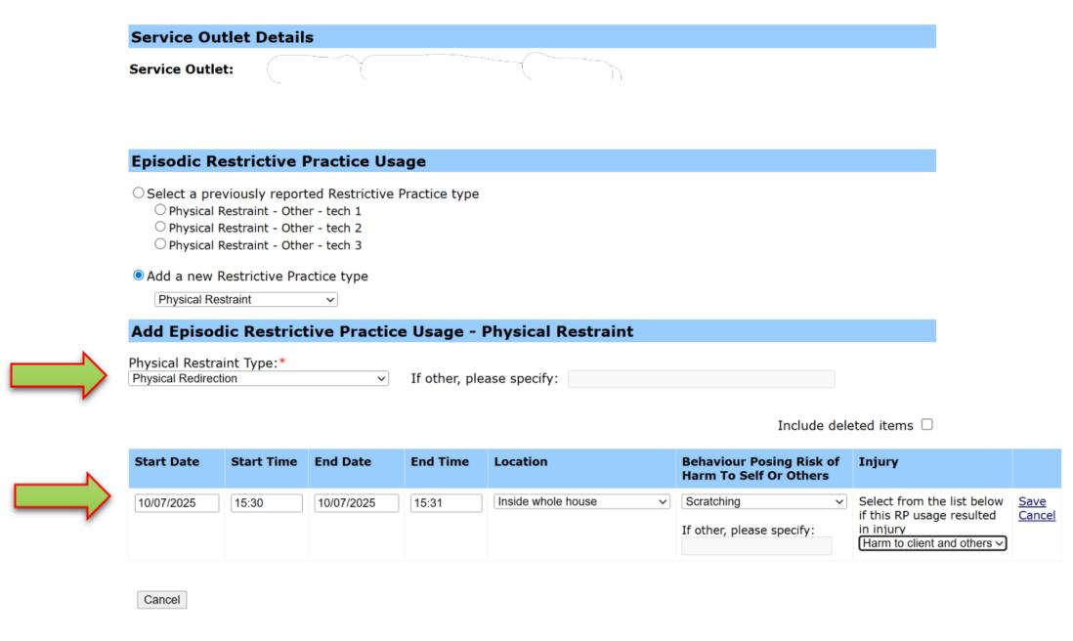
The information captured for Episodic Restrictive Practice Usage for Physical Restraint includes:
- Physical Restraint Type
- Start Date
- Start Time
- End Date
- End Time
- Location
- Primary Behaviour Posing Risk to Harm to Self Or Others
- Injury – only if the use of the restrictive practice resulted in an injury, not the behaviour of concern

Restricted Access to Objects (RATO)
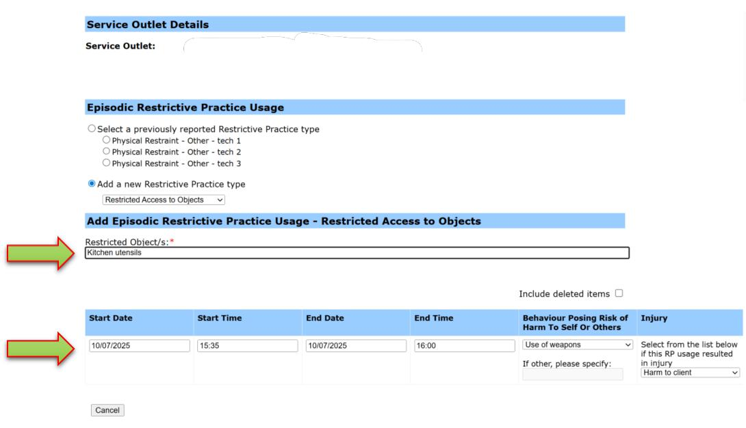
The information captured for Episodic Restrictive Practice Usage for Restricted Access to Objects includes:
- Restricted Object/s – List the specific objects which are restricted
- Start Date
- Start Time
- End Date
- End Time
- Primary Behaviour Posing Risk to Harm To Self Or Others
- Injury – only if the use of the restrictive practice resulted in an injury, not the behaviour of concern

Seclusion
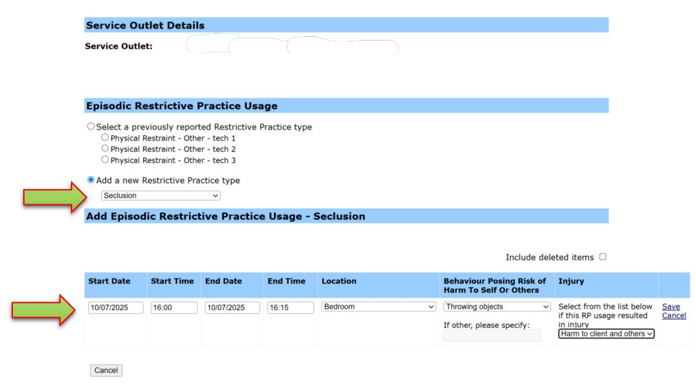
The information captured for Episodic Restrictive Practice Usage for Seclusion includes:
- Start Date
- Start Time
- End Date
- End Time
- Location
- Primary Behaviour Posing Risk to Harm To Self Or Others
- Injury – only if the use of the restrictive practice resulted in an injury, not the behaviour of concern

Episodic Restrictive Practice - Add Usage to An Existing Restrictive Practice Type
With the Restrictive Practice Summary page on display for the Service User:
- Select the Service Outlet where the Restricted Practice occurred.
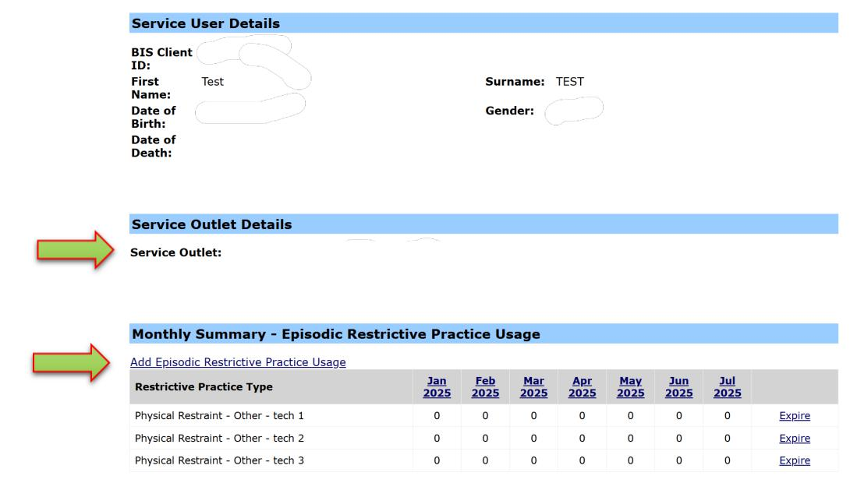
- Select the Add Episodic Restrictive Practice Usage hyperlink.

- Choose Select a previously reported Restrictive Practice type and select the relevant Restrictive Practice Type from the list.
- Select Add new instance of use hyperlink.
Note: In this example the previously reported Physical Restraint is selected, the details will change for each different Restrictive Practice Type. Refer to pages 17 to 21 for details.
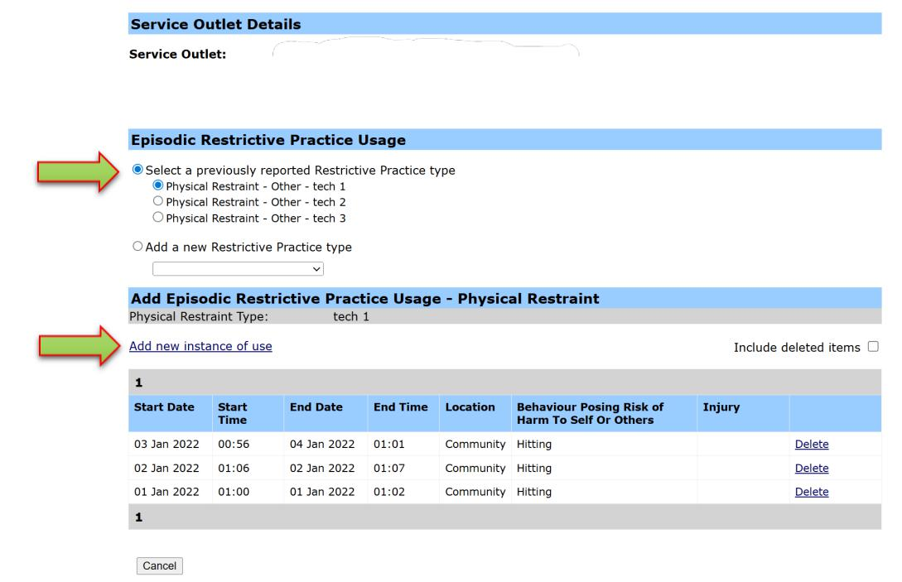

- Enter the details of the Episodic Restrictive Practice Usage.
- Start Date
- Start Time
- Primary Behaviour Posing Risk of Harm to Self or Others
- Injury – only if the use of the restrictive practice resulted in an injury, not the behaviour of concern.
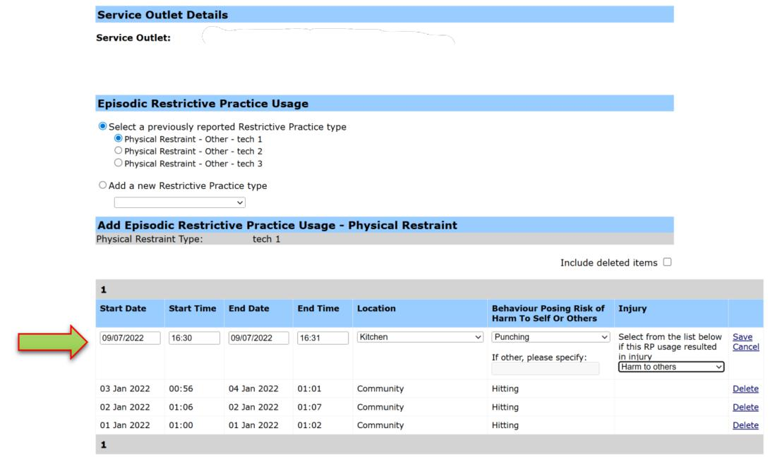

- Select Save.
Upon saving the new Restrictive Practice Type and summary of Usage display on the Service User’s Add Episodic Restrictive Practice Usage page. Alternatively, select the Cancel hyperlink to return to the Restrictive Practice Summary page for the Service User.

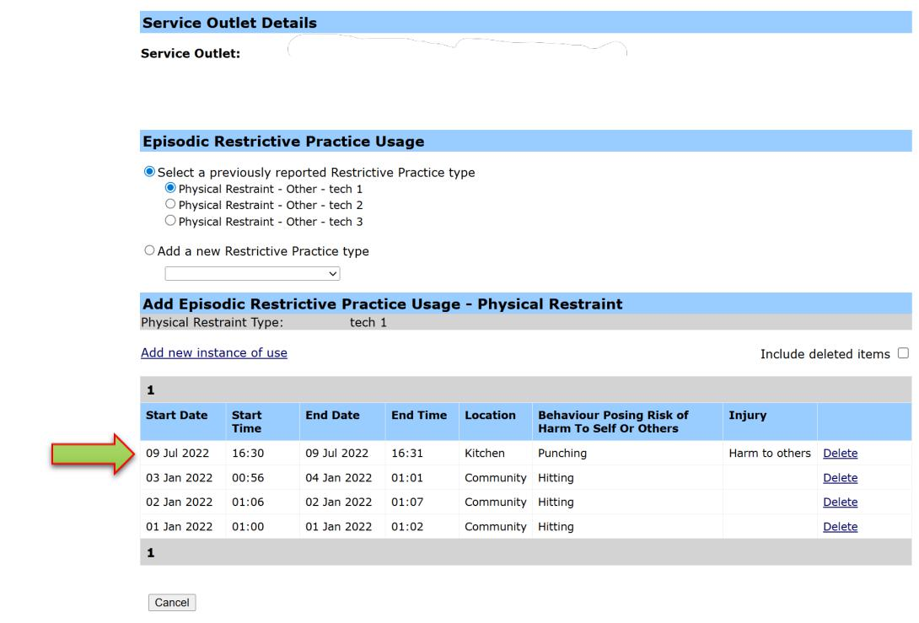
Displays the Episodic Restrictive Practice Usage page with the recorded Usage, see the following example.

Routine Restrictive Practice – Add a New Restrictive Practice Type
With the Restrictive Practice Summary page on display for the Service User:
- Select the Service Outlet where the Restricted Practice occurred.
- Select the Add Routine Restrictive Practice Usage hyperlink to display the Add Routine Restrictive Practice Usage page.
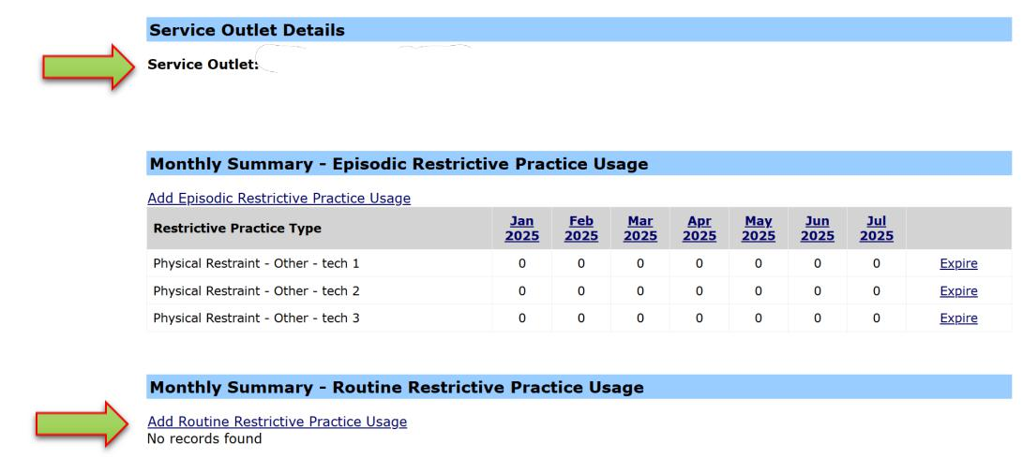
Note: If no Routine Usage has been entered for the Service User, the only option is to add a new Restrictive Practice Type.

Chemical Restraint Fixed Dose
- Select the drop-down list for Add a new Restrictive Practice type.
- The list displays the Restrictive Practice types:
- Chemical Restraint Fixed Dose
- Containment
- Mechanical Restraint
- Restricted Access to Objects
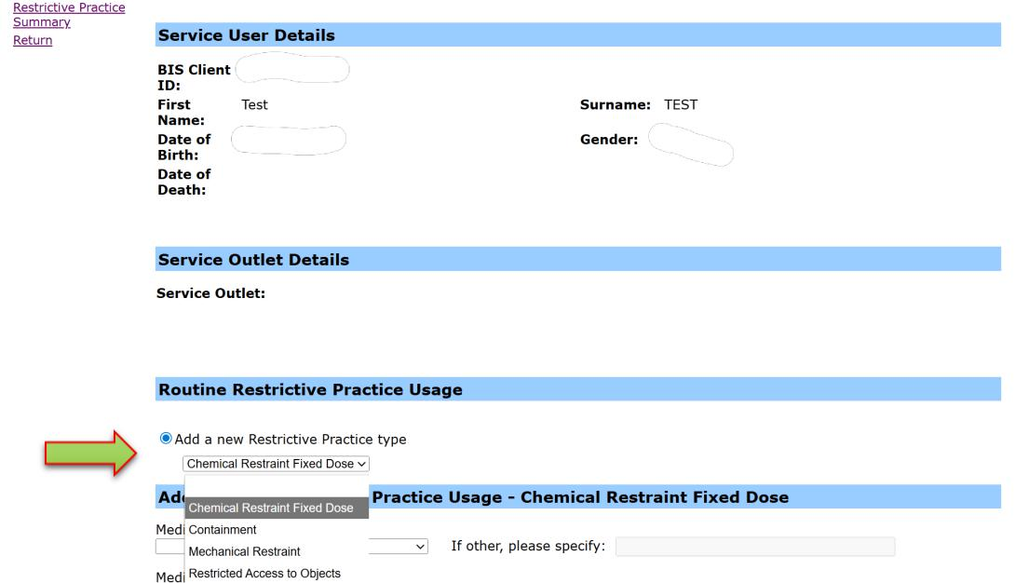
- Select the Restrictive Practice type.

Note: In this example Chemical Restraint Fixed Dose is selected, the details will change for each different Restrictive Practice Type. Refer to pages 29 to 31 for details.

- Enter the following information:
- Medication
- Medication Amount
- Medication Frequency
- Prescribed by
- Start Date
- End Date
- Primary Behaviour Posing Risk to Harm To Self Or Others
- Injury – only if the use of the restrictive practice resulted in an injury, not the behaviour of concern
- Select ‘Add’ button.
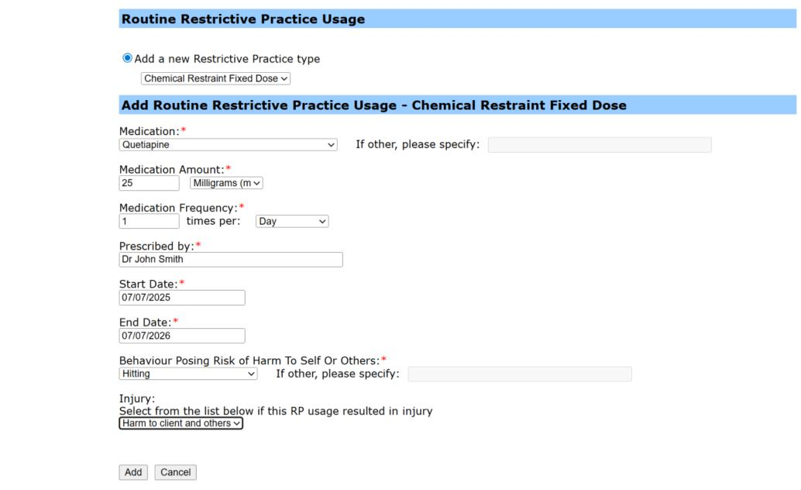
Upon adding the new Restrictive Practice Type, the user may continue to add instances of use to the Restrictive Practice Type by selecting the Add Routine Restrictive Practice Usage hyperlink (Page 32). Alternatively, select the ‘Cancel’ button to return to the Restrictive Practice Summary page for the Service User.

Containment
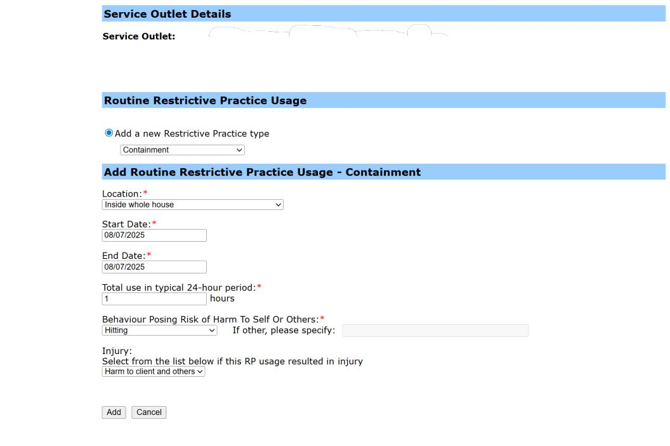
The information captured for Routine Restrictive Practice Usage for Containment includes:
- Location
- Start Date
- End Date
- Total use in typical 24-hour period
- Primary Behaviour Posing Risk to Harm To Self Or Others
- Injury – only if the use of the restrictive practice resulted in an injury, not the behaviour of concern.

Mechanical Restraint
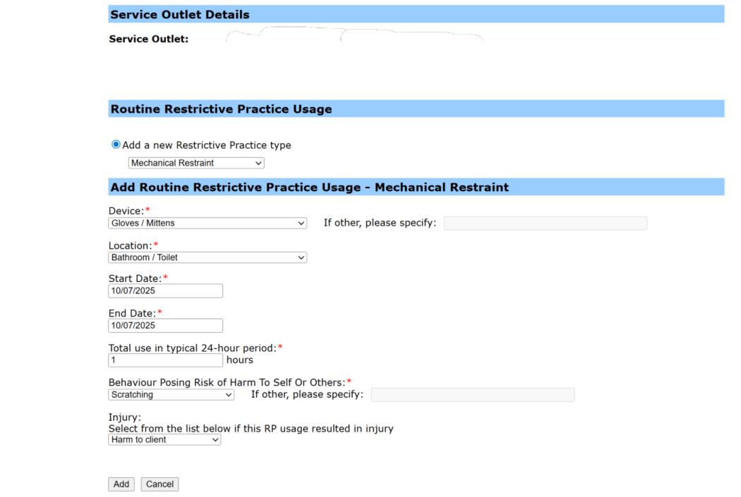

The information captured for Routine Restrictive Practice Usage for Mechanical Restraint includes:
- Device
- Location
- Start Date
- End Date
- Total use in typical 24-hour period
- Primary Behaviour Posing Risk to Harm to Self or Others
- Injury – only if the use of the restrictive practice resulted in an injury, not the behaviour of concern.

Restricted Access to Objects
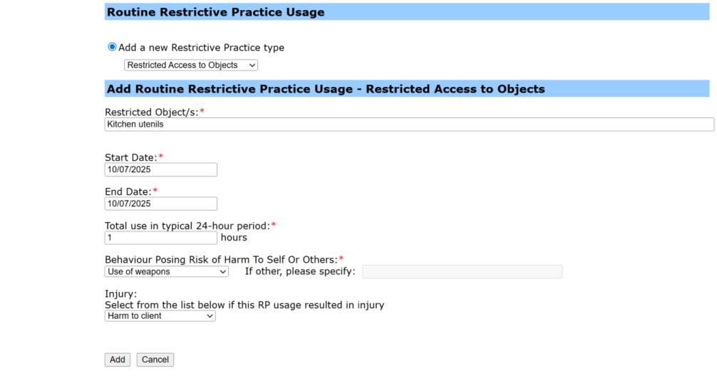

The information captured for Routine Restrictive Practice Usage for Restricted Access to Objects includes:
- Restricted Object/s
- Start Date
- End Date
- Total use in typical 24-hour period
- Primary Behaviour Posing Risk to Harm To Self Or Others
- Injury – only if the use of the restrictive practice resulted in an injury, not the behaviour of concern.

Routine Restrictive Practice - Add usage to an existing Restrictive Practice Type
With the Restrictive Practice Summary page on display for the Service User:
- Select the Service Outlet where the Restricted Practice occurred.
- Select the Add Routine Restrictive Practice Usage hyperlink.
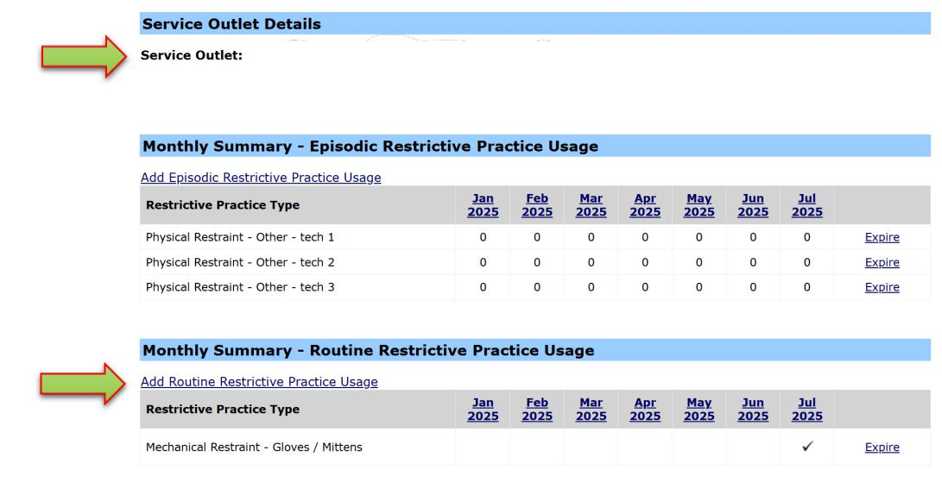
- Choose Select a previously reported Restrictive Practice type.
Note: In this example the previously reported Mechanical Restraint is selected the details will change for each different Restrictive Practice Type. Refer to pages 26 to 31 for details.
- Enter the details of the Routine Restrictive Practice Usage. In this example the previously reported Mechanical Restraint is selected and the following details completed.
- Start Date
- End Date
- Primary Behaviour Posing Risk to Harm to Self or Others
- Injury – only if the use of the restrictive practice resulted in an injury, not the behaviour of concern.
- Select ‘Add’ button.
Upon adding the new Restrictive Practice Type, the user may continue to add instances of use to the Restrictive Practice Type by selecting the Add Routine Restrictive Practice Usage hyperlink. Alternatively, select the ‘Cancel’ button to return to the Restrictive Practice Summary page for the Service User.
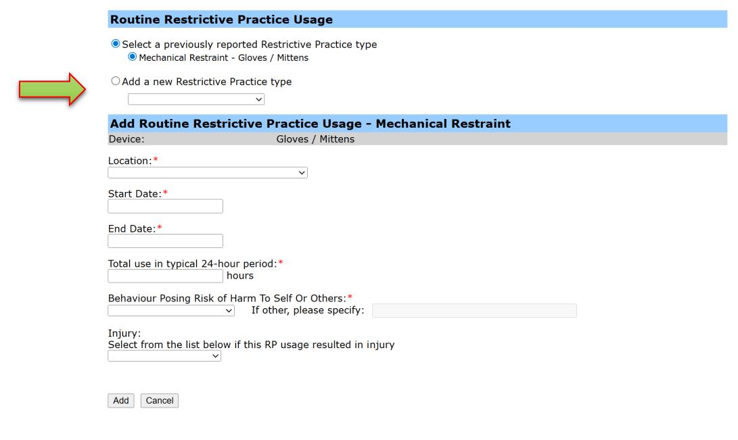

Displays the Routine Restrictive Practice Usage page with the recorded Restrictive Practice used, see the following example.
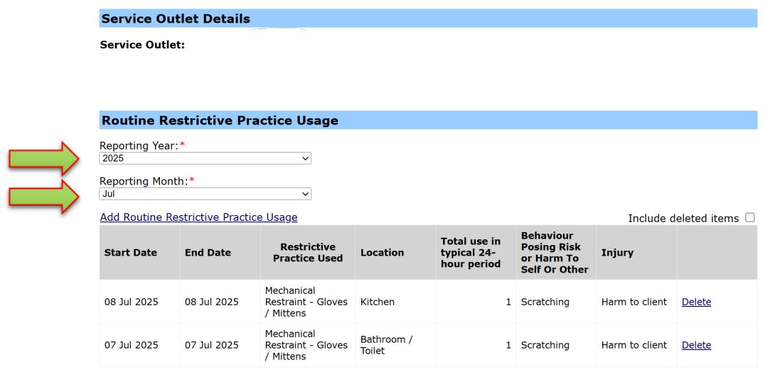
Tip:
- To view (or add to) other months / years reporting, change the dropdown values. The screen will automatically refresh, showing any entries which have been made for this combination.

Housekeeping Tips

Service User Does Not Have Restrictive Practice Approval
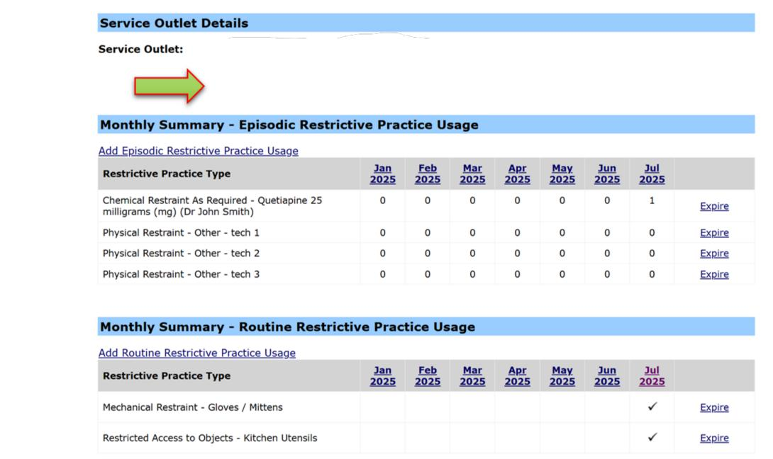
Where the Service User does not have a Restrictive Practice approval for the selected Service Outlet at the current date, a warning will display. Restrictive Practice Usage can still be recorded for the Service User. The processing of the Form 6-4 Notification of Approval or Consent for the use of restrictive practices is a priority. If you are continuing to receive this message, please contact the region where the Form 6-4 was sent.

Monthly Summary
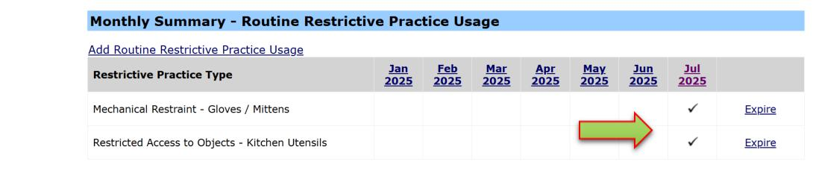
Once a Restrictive Practice usage has been recorded for a Service User, upon saving the entry, the Restrictive Practice Summary page displays a summary table of Restrictive Practice Usage for the current month and the prior six months. On the following example selecting the month/year hyperlink (Jul 2025) the Usage recorded will be displayed with detail of the Restrictive Practice Usage for the selected month.

Expire and Un-Expire a Restrictive Practice Type
On the Restrictive Practice Summary page, the summary table of Restrictive Practice Usage for the current month and the prior six months displays each Type recorded for the Service User. The Expire hyperlink enables the Restrictive Practice Type to be expired and no further Usage can be recorded for that Type. Once a Type has been Expired the summary displays an Un-expire hyperlink where the Type can be enabled again by selecting the Un-expire hyperlink.
Expiring Restrictive Practice Types that are not currently being used can be useful to keep the list of previously reported Restricted Practice Types relevant and to minimise the risk of incorrect data entry.
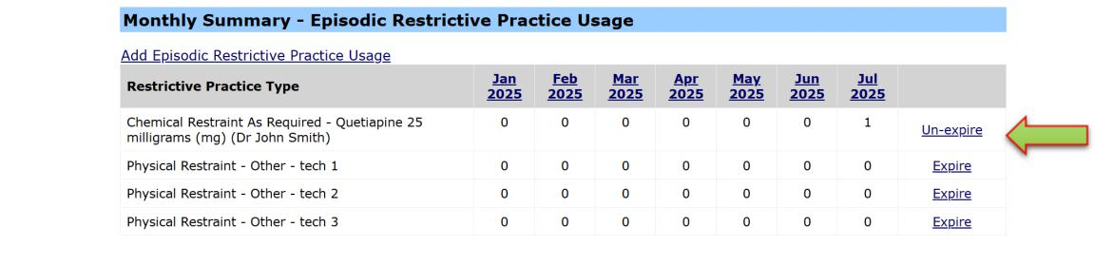
The Restrictive Practice Type ‘Chemical Restraint as Required’ displays in the following example as being expired with an Un-expire hyperlink.

Delete Restrictive Practice Usage
A Delete hyperlink displays on each Restrictive Practice Usage record. Selecting the Delete hyperlink will display a dialog box confirming the deletion. Selecting OK will delete the Usage record. Select the checkbox ‘Include deleted items’ to display Usage records with a Deleted status.
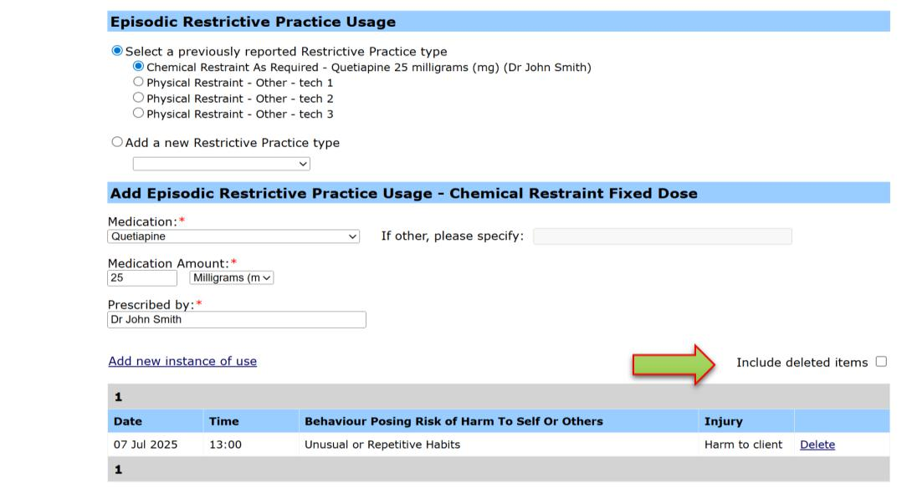
Tip:
- Where you can expire a Restrictive Practice Type, (to then un-expire it as required later on), instances of use can only be deleted. Once deleted, they cannot be restored (un-deleted) and if the entry is required, it must be re-entered.

Authorisation
Once the data entry of the Restrictive Practice Usage information has occurred for a Service User and Service Outlet, this information is to be “authorised”. The authorisation step indicates that Restrictive Practice Usage submission is complete for Service Outlet, Service User and reporting month.

Reports
The following reports are available within ODC:

Restrictive Practice Monthly Checklist
The monthly reporting checklist provides an overview of the reporting
status for each Service Outlet. The summary will indicate:
- Service Outlets with nothing more to do – i.e. no reporting is expected, or alternatively reporting has been finalised for each Service User associated with the Service Outlet.
- Service Outlets that have Service Users that have not yet been authorised. The system will prompt the user to authorise the Restrictive Practice Usage information.
- Service Outlets that have Service Users that were expected to report, but have not yet recorded any instances of use. The system will prompt the user to enter the Restrictive Practice Usage information.

Client Record of Restrictive Practice Usage Report
For evidence of reporting Restrictive Practice Usage, this report will allow a Service Provider to generate and export a PDF report showing Restrictive Practice Usage information for:
- One, many or all Service Outlets
- One, many or all Clients
- One, many or all Restrictive Practice Types
- A specified date range.

Restrictive Practice Usage Report
Service Providers are able to generate and extract data on Restrictive Practice Usage to utilise for their own reporting requirements.

Compliance Report
The Restrictive Practice Compliance Report is provided to allow Service Providers the ability to monitor their own compliance around the reporting and recording of usage of restrictive practices. (refer to USER GUIDE – Compliance Report for more information).

Bulk Import
Organisations with a large number of clients may use the Bulk Import functionality to assist in the data entry of Restrictive Practice Usage information. This bulk import will be used to record the Restrictive Practice usage details for one or more Service Users and Service Outlets in ODC.

In the cases of in-home respite or Community Access Supports, this would be the outlet where the staff providing the service are deployed / administered from. This must also be the same outlet number as submitted per the Form 6-4 Notification of Approval or Consent to the use of Restrictive Practices.
This is the generic name of the medication.
In the cases of in-home respite or Community Access Supports, this would be the outlet where the staff providing the service are deployed / administered from. This must also be the same outlet number as submitted per the Form 6-4 Notification of Approval or Consent to the use of Restrictive Practices.
This is the generic name of the medication.

