Department of Families, Seniors, Disability Services and Child Safety

Recording Restrictive Practice Usage in ODC for Seclusion
This information sheet provides practitioners, service providers and disability support workers with information about reporting of Restrictive Practice usage in the Online Data Collection system
(ODC) for Seclusion. Restrictive Practice usage information is required to be reported to the
Department each month. Details about the use of Seclusion are to be recorded in ODC for each time that Seclusion is used as a Restrictive Practice within the month.
Recording the use of Seclusion in ODC
Each use of Seclusion is to be recorded as a separate Restrictive Practice instance of use in ODC. Seclusion is recorded as episodic usage only. For more information on the definition of Episodic
usage, please refer to the Restrictive Practice Collection using ODC – Quick Reference Guide.

An example of Seclusion
Kevin is 23 years of age and has moved from his family home to rent a house with two other men. The men are provided supported accommodation services by a non-government service provider. Kevin moved from home because his mother was sick, and she was his only carer at home. Kevin is unable to speak more than a few words and is not legally able to make decisions for himself. His mother is his informal guardian. After two weeks in his new home, Kevin pushes one of the other men in the house and starts to pull things off shelves and out of cupboards. This is dangerous and someone is at risk of being hurt. Staff try to calm Kevin, but he becomes more upset and so the staff member guides Kevin out into the backyard and closes and locks the door so he cannot come back into the house. The staff member then cares for the other two men and cleans up inside. Kevin cannot leave the backyard as it is fully fenced, and he is unable to come back inside without staff opening the door. The staff member and the team cannot work out why Kevin is behaving this way and have had to place him in the backyard to protect everyone one other time. He calms down after about half an hour in the backyard.

Reporting Episodic Seclusion in ODC
Login to ODC to display the Online Data Collection page:
- Select Restrictive Practice drop down list and select Restrictive Practice Service User hyperlink to display the Search Restrictive Practice Service User page.
- Enter the Service User’s details.
- Select ‘Search’ button.
- Select from the search result, the Service User’s Surname hyperlink to display the Service Users Details page.
- Select Restrictive Practice Summary from the Service User menu to display the Restricted Practice Summary page.
- Select the Service Outlet where the Restricted Practice occurred.
- Select Add Routine Restrictive Practice Usage hyperlink.

Note this example shows no previous recording of Restrictive Practice Usage and this is the first Usage recorded for the Service User and the Service Outlet. This is the only time that Seclusion for the Service User and Service Outlet is to be entered. Every other time an instance of use is added to the existing “Seclusion” Restrictive Practice Type, so that all Usage is reported under the same Restrictive Practice Type. This allows trending of usage so it can be determined if this Restrictive Practice is being eliminated or reduced in Usage.
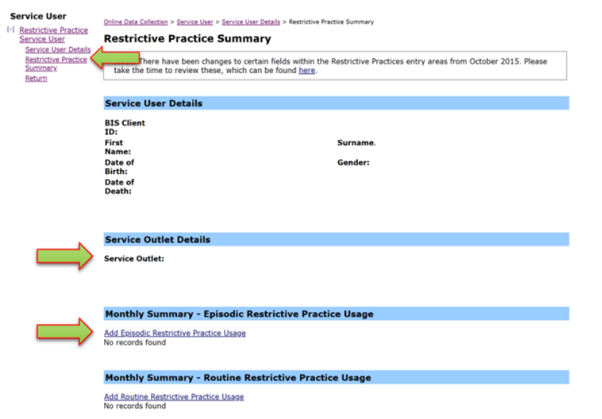
- Select Seclusion for the Add a new Restrictive Practice type.
- Select Add new instance of use hyperlink.
- Enter the following details:
  - Start Date – 02/12/xx
  - Start Time – 0930
  - End Date – 02/12/xx
  - End Time – 1000
  - Location – Yard/Garden/Driveway. (If not listed, select Other from the drop list and provide the details in the adjoining field - If Other, please specify.)
  - Behaviour Posing Risk of Harm to Self Or Others – Hitting. (Record this as the main behaviour that was presented and the behaviour that led to the use of the Restricted Practice.)
  - Injury – Harm to others. (Injury is only required to be entered when an injury was sustained as a result of using the Restrictive Practice.)
- Select the Save hyperlink.
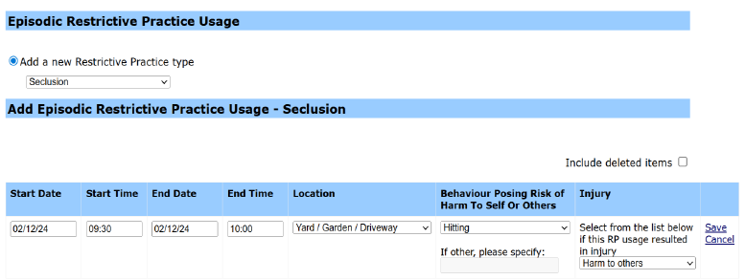

Data Entry Tips
- when entering the date, the year can be shortened to 2 digits. E.g., 13/09/xxxx can be entered as 13/9/xx
- when entering the time, no “:” is required to separate the hours and minutes. The time is recorded in 24-hour format. E.g., 09:10AM can be entered as 910, or 1:17PM can be recorded as 1317.

Reporting Routine Seclusion in ODC is not permitted and therefore not available as a selectable option.

