Department of Families, Seniors, Disability Services and Child Safety

Recording Restrictive Practice Usage in ODC for Restricted Access to Objects
This information sheet provides practitioners, service providers and disability support workers with information about reporting of Restrictive Practice usage in the Online Data Collection system
(ODC) for Restricted Access to Objects. Restrictive Practice usage information is required to be
reported to the Department each month. Details about the use of Restricted Access to Objects are to be recorded in ODC for each time that Restricted Access to Objects is used as a Restrictive
Practice within the month.
Recording the use of Restricted Access to Objects in ODC
Each use of Restricted Access to Objects is to be recorded as a separate Restrictive Practice
instance of use in ODC. Restricted Access to Objects can be recorded for both episodic and
routine usage. For more information on the definitions of Routine and Episodic usage, please refer to the Restrictive Practice Collection using ODC – Quick Reference Guide.

An example of Restricted Access to Objects
Monica is 33 years of age and lives with another woman in a rented home. They are both supported in their home by paid staff. When Monica was a child, she drank washing up detergent and had to go to hospital. Her parents also said they kept the refrigerator locked as she would drink all the milk and water kept in the refrigerator. The staff have seen her try to drink the washing liquid and stopped her in time and she has been taking all the milk from the refrigerator. Monica also drinks quickly and can cough from choking if staff do not remind her to slow down. Staff are worried they will not be able to stop her from drinking something dangerous and want to lock away anything that Monica may drink when they are not around. Staff who support her feel that locking these away is the only way to keep her safe. They cannot be with Monica every
moment of the day or night to support both Monica and her flat mate. Monica’s friend Lorna helps Monica with decisions. Monica does not have any other behaviours of concern.

Reporting Routine Restricted Access to Objects in ODC
Login to ODC to display the Online Data Collection page:
- Select Restrictive Practice drop down list and select Restrictive Practice Service User hyperlink to display the Search Restrictive Practice Service User page.
- Enter the Service User’s details.
- Select ‘Search’ button.
- Select from the search result the Service User’s Surname hyperlink to display the Service Users Details page.
- Select Restrictive Practice Summary from the Service User menu to display the Restricted Practice Summary page.
- Select the Service Outlet where the Restricted Practice occurred.
- Select Add Routine Restrictive Practice Usage hyperlink.

Note this example shows no previous recording of Restrictive Practice Usage and this is the first Usage recorded for the Service User and the Service Outlet. This is the only time that Restricted Access to Objects for the Service User and Service Outlet is to be entered. Every other time an instance of use is added to the existing “Restricted Access to Objects” Restrictive Practice Type, so that all Usage is reported under the same Restrictive Practice Type. This allows trending of usage so it can be determined if this Restrictive Practice is being eliminated or reduced in Usage.
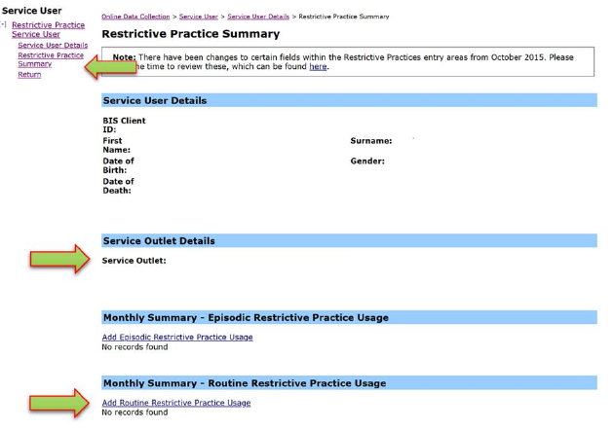
- Select Restricted Access to Objects for the Add a new Restrictive Practice type.
- Enter the following details:
  - Restricted Object/s – List the objects which the person has restricted access to (text field
with 100-character limit)
  - Start Date – The start date for the date range of usage
  - End Date – The end date for the date range of usage
  - Total use in typical 24-hour period – the typical (average) hours, in a 24-hour period, where this restrictive practice is in effect (14 hours would be recorded as 14.00)
  - Behaviour Posing Risk of Harm to Self Or Others – Record this as the main behaviour that was presented and the behaviour led to the use of the Restricted Practice.
  - Injury – only required to be entered if an injury was sustained as a result of using the Restrictive Practice.
- Select the ‘Add’ button.
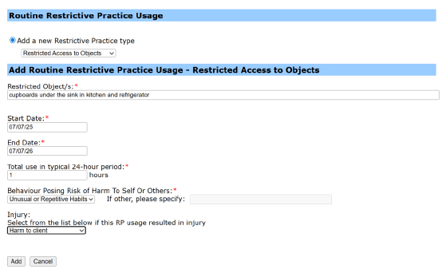

Reporting Episodic Restricted Access to Objects in ODC
Login to ODC to display the Online Data Collection page:
- Select Restrictive Practice drop down list and select Restrictive Practice Service User hyperlink to display the Search Restrictive Practice Service User page.
- Enter the Service User’s details.
- Select ‘Search’ button.
- Select from the search result the Service User’s Surname hyperlink to display the Service User Details page.
- Select Restrictive Practice Summary from the Service User menu to display the Restricted Practice Summary page.
- Select the Service Outlet where the Restricted Practice occurred.
- Select Add Episodic Restrictive Practice Usage hyperlink.

Note this example shows no previous recording of Restrictive Practice Usage and this is the first Usage recorded for the Service User and the Service Outlet. This is the only time that Restricted Access to Objects for the Service User and Service Outlet is to be entered. Every other time an instance of use is added to the existing “Restricted Access to Objects” Restrictive Practice Type, so that all Usage is reported under the same Restrictive Practice Type. This allows trending of
usage so it can be determined if this Restrictive Practice is being eliminated or reduced in Usage.
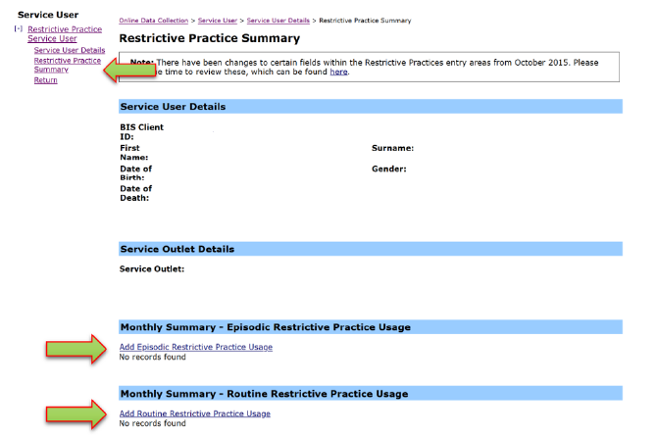
- Select Restricted Access to Objects for the Add a new Restrictive Practice type
- Select Add new instance of use hyperlink
- Enter the following details:
- Start Date – The date the usage of Restricted Access to Objects commenced
- Start Time – The time the usage of Restricted Access to Objects commenced
- End Date – The date the usage of Restricted Access to Objects ceased (must be less than 24 hours)
- End Time – The time the usage of Restricted Access to Objects ceased (must be less than 24 hours)
- Behaviour Posing Risk of Harm to Self Or Others – Record this as the main behaviour that was presented and the behaviour led to the use of the Restricted Practice.
- Injury – Injury is only required to be entered when an injury was sustained as a result of using the Restrictive Practice. Not the behaviour of concern.
- Select the Save hyperlink
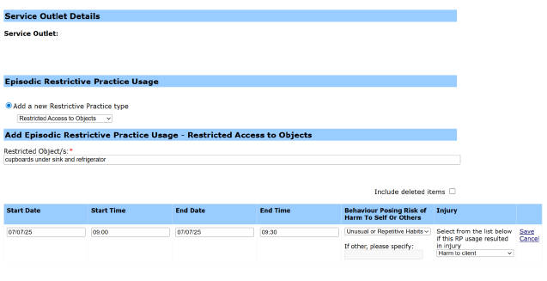

Data entry tips
- When entering the date, the year can be shortened to 2 digits. E.g. 13/09/20xx can be entered as 13/9/xx
- When entering the time, no “:” is required to separate the hours and minutes. The time is recorded in 24-hour format. E.g. 09:10AM can be entered as 910, or 1:17PM can be record.

