Department of Families, Seniors, Disability Services and Child Safety

Recording Restrictive Practice Usage in ODC for Physical Restraint
This information sheet provides practitioners, service providers and disability support workers with information about reporting of Restrictive Practice usage in the Online Data Collection system (ODC) for Physical Restraint. Restrictive Practice usage information is required to be reported to the Department each month. Details about the use of Physical Restraint are to be recorded in ODC for each time that Physical Restraint is used as a Restrictive Practice within the month.
Recording the use of Physical Restraint in ODC
Each use of Physical Restraint is to be recorded as a separate Restrictive Practice instance of use in ODC. Physical Restraint is recorded as episodic usage only. For more information on the definition of Episodic usage, please refer to the Restrictive Practice Collection using ODC – Quick Reference Guide.

An example of Physical Restraint
Janice is 18 years of age and is supported by staff from an accommodation service to live in her own apartment. Three days per week she works at a plant nursery and is supported by a community access service provider. Janice is not legally able to make decisions for herself and her parents make these for her.
At work Janice has started to pinch her support worker. This was something she has done in the past at school with teachers and fellow students and occasionally at home with her sister. The advice from her parents has been to hold her hand to prevent Janice from pinching you and say “no” and then guide her hand back to the task she is doing. This is the action staff have been using.
Reporting Episodic Physical Restraint in ODC
Login to ODC to display the Online Data Collection page:
- Select Restrictive Practice drop down list and select Restrictive Practice Service User hyperlink to display the Search Restrictive Practice Service User page.
- Enter the Service User’s details.
- Select ‘Search’ button.
- Select from the search result the Service User’s Surname hyperlink to display the Service Users Details page.
- Select Restrictive Practice Summary from the Service User menu to display the Restricted Practice Summary page.
- Select the Service Outlet where the Restricted Practice occurred.
- Select Add Episodic Restrictive Practice Usage hyperlink.
Note this example shows no previous recording of Restrictive Practice Usage and this is the first Usage recorded for the Service User and the Service Outlet. This is the only time that Physical Restraint for the Service User and Service Outlet is to be entered. Every other time an instance of use is added to the existing “Physical Restraint” Restrictive Practice Type, so that all Usage is reported under the same Restrictive Practice Type. This allows trending of usage so it can be determined if this Restrictive Practice is being eliminated or reduced in Usage.
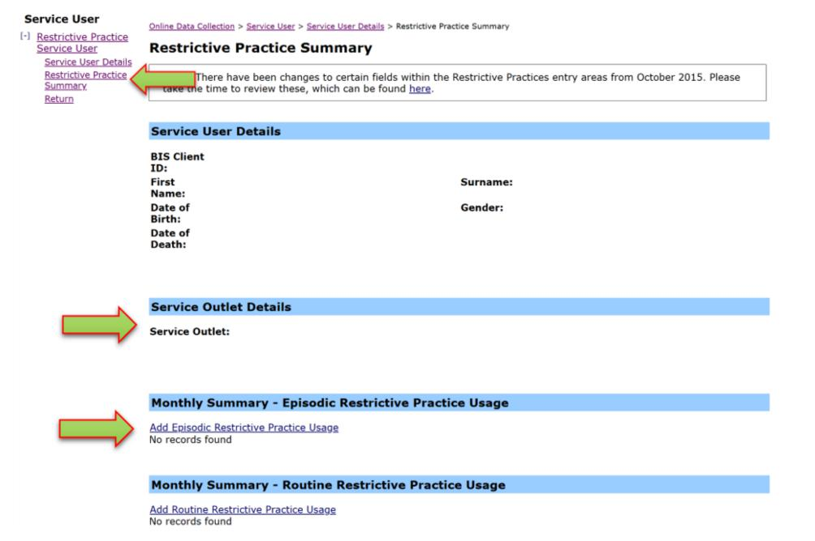
- Select Physical Restraint for the Add a new Restrictive Practice type
- Select the Physical Restraint Type – in this example we select “One person guiding”
- Select Add new instance of for the Add a new Restrictive Practice type use hyperlink
- Enter the following details:
- Start Date – The date the usage of physical restraint commenced
- Start Time – The time the usage of physical restraint commenced
- End Date – The date the usage of physical restraint ceased (must be less than 24 hours)
- End Time – The time the usage of physical restraint ceased (must be less than 24 hours)
- Location – Select from the drop-down list. If not listed, select Other from the drop list and provide the details in the adjoining field - If Other, please specify.
- Behaviour Posing Risk of Harm to Self Or Others – Record this as the main behaviour that was presented and the behaviour led to the use Restricted Practice.
- Injury – Injury is only required to be entered when an injury was sustained as result of using the Restrictive Practice. Not the behaviour of concern.
- Select the Save hyperlink
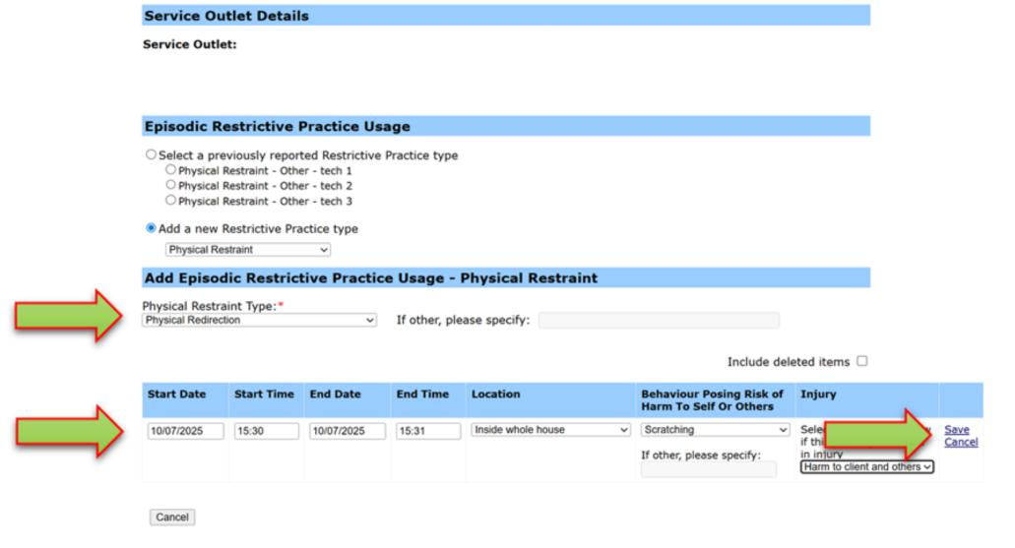

Data entry tips
- When entering the date, the year can be shortened to 2 digits. E.g., 13/09/201x can be entered as 13/9/1x
- When entering the time, no “:” is required to separate the hours and minutes. The time is recorded in 24-hour format. E.g., 09:10AM can be entered as 910, or 1:17PM can be recorded as 1317.
Reporting Routine Physical Restraint in ODC in not permitted, and therefore not available as a selectable option.

