Department of Families, Seniors, Disability Services and Child Safety

Recording Restrictive Practice Usage in ODC for Mechanical Restraint
This information sheet provides practitioners, service providers and disability support workers with information about reporting of Restrictive Practice usage in the Online Data Collection system
(ODC) for Mechanical Restraint. Restrictive Practice usage information is required to be reported to the Department each month. Details about the use of Mechanical Restraint are to be recorded in
ODC for each time that Mechanical Restraint is used as a Restrictive Practice within the month.
Recording the use of Mechanical Restraint in ODC
Rory is 25 years of age and has started to scratch his arms, legs and face until they bleed. He has many scars on his body due to scratching in the past. He rents a house with three other adults, and they have 24 hours support from staff of a service. When Rory’s parents could no longer provide
support to Rory, Rory’s brother became his formal guardian for decisions by the Queensland Civil and Administrative Tribunal. To prevent Rory from scratching, his brother tells staff that in the past his parents and school placed Rory in gloves. The gloves had Velcro that held the gloves around his wrist making it impossible for Rory to remove them. This seems the only option to prevent Rory from harming himself.
Reporting Routine Mechanical Restraint in ODC
Login to ODC to display the Online Data Collection page:
- Select Restrictive Practice drop down list and select Restrictive Practice Service User hyperlink to display the Search Service User page.
- Enter the Service User’s details.
- Select ‘Search’ button.
- Select from the search result the Service User’s Surname hyperlink to display the Service Users Details page.
- Select Restrictive Practice Summary from the Service User menu to display the Restricted Practice Summary page.
- Select the Service Outlet where the Restricted Practice occurred.
- Select Add Routine Restrictive Practice Usage hyperlink.
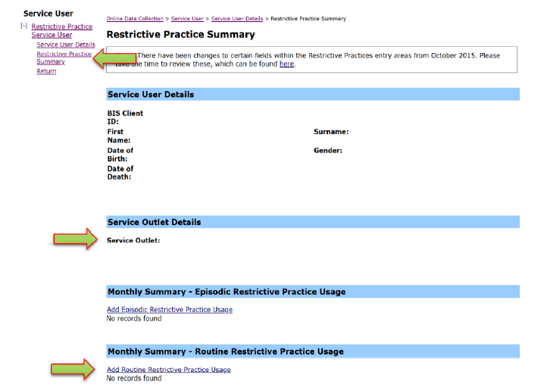
Note this example shows no previous recording of Restrictive Practice Usage and this is the first Usage recorded for the Service User and the Service Outlet. This is the only time that Mechanical Restraint for the Service User and Service Outlet is to be entered. Every other time an instance of use is added to the existing “Mechanical Restraint” Restrictive Practice Type, so that all Usage is reported under the same Restrictive Practice Type. This allows trending of usage so it can be determined if this Restrictive Practice is being eliminated or reduced in Usage.

- Select Mechanical Restraint for the Add a new Restrictive Practice type.
- Enter the following details:
  - Device – Select the device used, from the drop-down list. If not listed, select “Other” from the drop list and provide the details in the adjoining field - If Other, please specify.
  - Location – Select the location where the device was used, from the drop-down list. If not listed, select “Other” from the drop list and provide the details in the adjoining field - If Other, please specify.
  - Start Date – The start date for the date range of usage.
  - End Date – The end date for the date range of usage.
  - Total use in typical 24-hour period – the typical (average) hours, in a 24-hour period, where this restrictive practice is in effect (14 hours would be recorded as 14.00)
  - Behaviour Posing Risk of Harm to Self Or Others – Record this as the main behaviour that was presented and the behaviour led to the use of the Restricted Practice.
  - Injury – only required to be entered if an injury was sustained as a result of using the Restrictive Practice.
- Select the ‘Add’ button.
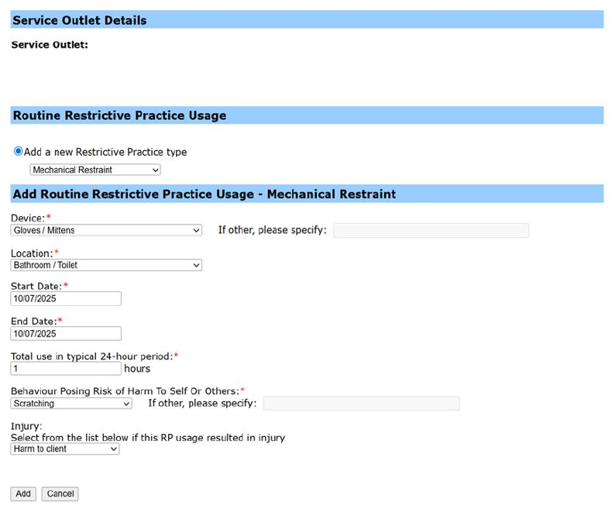

An example of Mechanical Restraint
Rebecca is a 22-year-old woman with an intellectual disability. Rebecca has a soft toy she carries with her at all times. If the soft toy is misplaced Rebecca becomes distressed and starts to suck on her hands. This has led to significant injury to her hands. In order to prevent her from sucking on her hands, Rebecca wears gloves on her hands until the soft toy is located.

Reporting Episodic Mechanical Restraint in ODC
Login to ODC to display the Online Data Collection page:
- Select Restrictive Practice drop down list and select Restrictive Practice Service User hyperlink to display the Search Restrictive Practice Service User page.
- Enter the Service User’s details.
- Select ‘Search’ button.
- Select from the search result the Service User’s Surname hyperlink to display the Service Users Details page.
- Select Restrictive Practice Summary from the Service User menu to display the Restricted Practice Summary page.
- Select the Service Outlet where the Restricted Practice occurred.
- Select Add Episodic Restrictive Practice Usage hyperlink.
Note this example shows no previous recording of Restrictive Practice Usage and this is the first Usage recorded for the Service User and the Service Outlet. This is the only time that Mechanical Restraint for the Service User and Service Outlet is to be entered. Every other time an instance of use is added to the existing “Mechanical Restraint” Restrictive Practice Type, so that all Usage is reported under the same Restrictive Practice Type. This allows trending of usage so it can be determined if this Restrictive Practice is being eliminated or reduced in Usage.

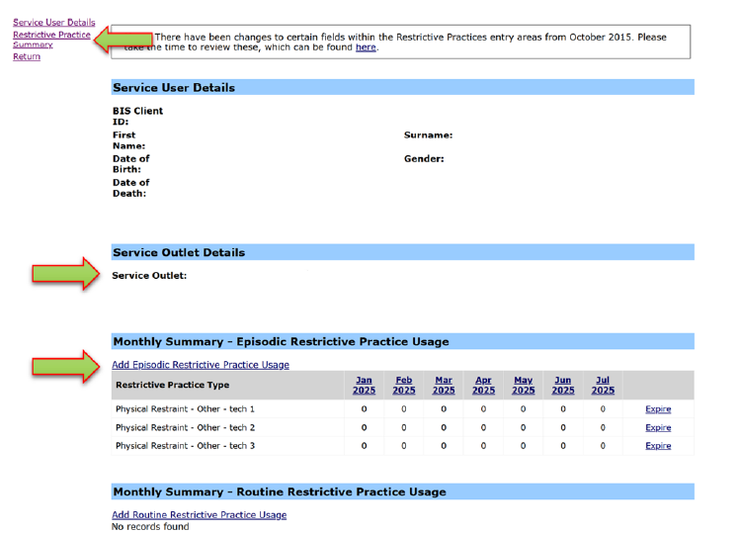
- Select Mechanical Restraint for the Add a new Restrictive Practice type.
- Select The Device – Select the device used, from the drop-down list. If not listed, select “Other” from the drop list and provide the details in the adjoining field - If Other, please specify.
- Select Add new instance of use hyperlink.
- Enter the following details:
  - Start Date – The date the usage of the device commenced
  - Start Time – The time the usage of the device commenced
  - End Date – The date the usage of the device ceased (must be less than 24 hours)
  - End Time – The time the usage of the device ceased (must be less than 24 hours)
  - Location – Select from the drop-down list. If not listed, select “Other” from the drop list and provide the details in the adjoining field - If Other, please specify.
  - Behaviour Posing Risk of Harm to Self Or Others – Record this as the main behaviour that was presented and the behaviour led to the use of the Restricted Practice.
  - Injury – only required to be entered if an injury was sustained as a result of using the Restrictive Practice.
- Select the Save hyperlink.
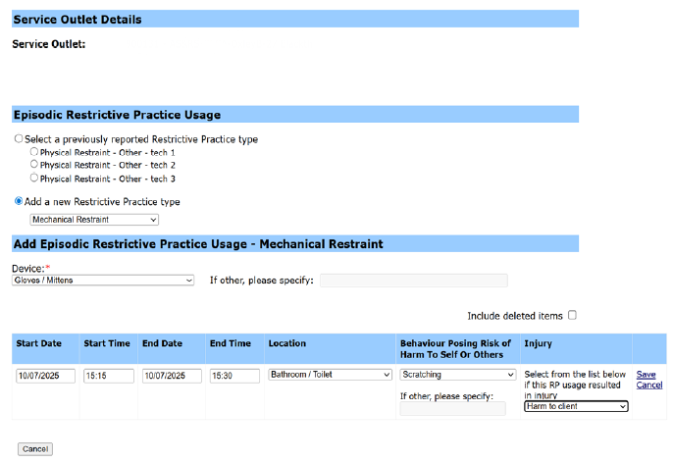

Data entry tips
- when entering the date, the year can be shortened to 2 digits. E.g. 13/09/xxxx can be entered as 13/9/xx
- when entering the time, no “:” is required to separate the hours and minutes. The time is recorded in 24-hour format. E.g. 09:10AM can be entered as 910, or 1:17PM can be recorded as 1317

