Department of Families, Seniors, Disability Services and Child Safety

Recording Restrictive Practice Usage in ODC for Containment
This information sheet provides practitioners, service providers and disability support workers with information about reporting of Restrictive Practice usage in the Online Data Collection system
(ODC) for Containment. Restrictive Practice usage information is required to be reported to the
Department each month. Details about the use of Containment are to be recorded in ODC for each time that Containment is used as a Restrictive Practice within the month.
Recording the use of Containment in ODC
Each use of Containment is to be recorded as a separate Restrictive Practice instance of use in ODC. Containment can be recorded for both episodic and routine usage. For more information on the definitions of Routine and Episodic usage, please refer to the Restrictive Practice Collection using ODC – Quick Reference Guide.

An example of Containment
Mary is 41 years of age and had a car accident when she was 30 years of age. Mary has a brain injury as a result of the accident and is no longer able to make decisions, she needs help to look after herself and someone to manage her money. Her parents have died so Mary moved into a house with 24-hour support by a supported accommodation service. The Queensland Civil and Administrative Tribunal made the Public Guardian her guardian for personal decisions and the Public Trust to assist with her money. Mary has left the house and visited neighbours’ houses, and she asked for cigarettes. She became upset when the neighbours said ‘no’, and she broke their window. After this the staff have made sure that Mary cannot leave the house without staff, so the doors are locked. She yells and swears at the staff when she cannot leave but after about an hour she calms, and they can talk with her, and she does other things. Staff have cigarettes for Mary and give them to her. The doctor has asked Mary to cut back on her cigarettes because of her health. The staff have tried a number of things to take her mind off cigarettes, but she is still trying to leave the house. The staff are concerned about what she will do so keep the doors locked.

Reporting Routine Containment in ODC
Login to ODC to display the Online Data Collection page:
- Select Restrictive Practice drop down list and select Restrictive Practice Service User hyperlink to display the Search Restrictive Practice Service User page.
- Enter the Service User’s details.
- Select ‘Search’ button.
- Select from the search result, the Service User’s Surname hyperlink to display the Service Users Details page.
- Select Restrictive Practice Summary from the Service User menu to display the Restricted Practice Summary page.
- Select the Service Outlet where the Restricted Practice occurred.
- Select Add Routine Restrictive Practice Usage hyperlink.

Note this example shows no previous recording of Restrictive Practice Usage and this is the
first Usage recorded for the Service User and the Service Outlet. This is the only time that
Containment for the Service User and Service Outlet is to be entered. Every other time an
instance of use is added to the existing “Containment” Restrictive Practice Type, so that all
Usage is reported under the same Restrictive Practice Type. This allows trending of usage so it can be determined if this Restrictive Practice is being eliminated or reduced in Usage.
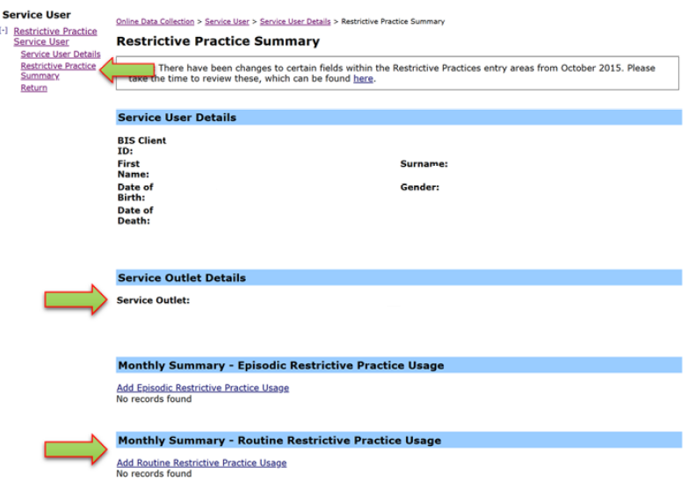
- Select Containment for the Add a new Restrictive Practice type.
- Enter the following details:
- Location – Select from the drop-down list. If not listed, select “Other” from the drop list and provide the details in the adjoining field - If Other, please specify.
- Start Date – The start date for the date range of usage
- End Date – The end date for the date range of usage
- Total use in typical 24-hour period – the typical (average) hours, in a 24-hour period, where this restrictive practice is in effect (14 hours would be recorded as 14.00)
- Behaviour Posing Risk of Harm to Self Or Others – Record this as the main behaviour that was presented and the behaviour led to the use of the Restricted Practice.
- Injury - only required to be entered if an injury was sustained as a result of using the Restrictive Practice.
- Select the Save hyperlink
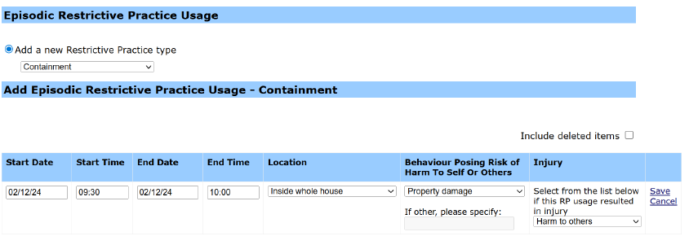

An example of Containment
Matt is a 41-year-old man with an intellectual disability who lives in his home with support staff. A yard maintenance person attends to the yard usually once every three weeks. Matt has been
known to try leave the house and try to use the maintenance equipment. When the maintenance person tries to stop Matt, he gets upset and scratches the maintenance person. A support staff member now stays with Matt in the rumpus room with the door locked to stop Matt from freely
going out into the yard without support staff and preventing Matt from harming the lawn
maintenance person.

Reporting Episodic Containment in ODC
Login to ODC to display the Online Data Collection page:
- Select Restrictive Practice drop down list and select Restrictive Practice Service User hyperlink to display the Search Restrictive Practice Service User page.
- Enter the Service User’s details
- Select ‘Search’ button.
- Select from the search result the Service User’s Surname hyperlink to display the Service Users Details page.
- Select Restrictive Practice Summary from the Service User menu to display the Restricted Practice Summary page.
- Select the Service Outlet where the Restricted Practice occurred.
- Select Add Episodic Restrictive Practice Usage hyperlink.
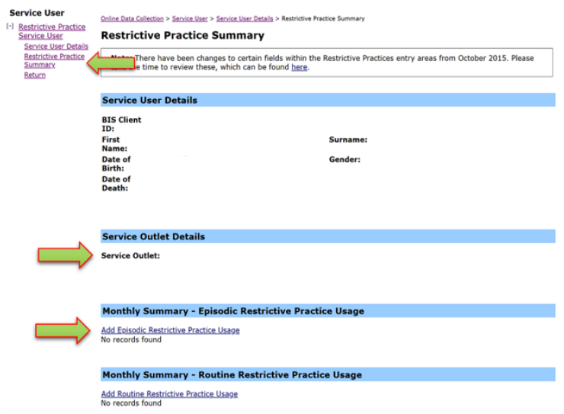
Note this example shows no previous recording of Restrictive Practice Usage and this is the first Usage recorded for the Service User and the Service Outlet. This is the only time that Containment for the Service User and Service Outlet is to be entered. Every other time an instance of use is added to the existing “Containment” Restrictive Practice Type, so that all Usage is reported under the same Restrictive Practice Type. This allows trending of usage so it can be determined if this Restrictive Practice is being eliminated or reduced in Usage.
- Select Containment for the Add a new Restrictive Practice type.
- Select Add new instance of use hyperlink
- Enter the following details:
  - Start Date – The date the Containment commenced
  - Start time – The time the Containment commenced
  - End Date – The date the Containment ceased (must be less than 24 hours)
  - End Time – The date the Containment ceased (must be less than 24 hours)
  - Location – Select from the drop-down list. If not listed, select “Other” from the drop list and provide the details in the adjoining field - If Other, please specify.
  - Behaviour Posing Risk of Harm To Self Or Others – Record this as the main behaviour that was presented and the behaviour led to the use of the Restricted Practice.
  - Injury - only required to be entered if an injury was sustained as a result of using the Restrictive Practice.
- Select the Save hyperlink.
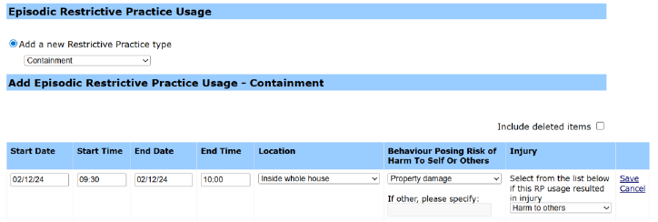

Data Entry Tips
- when entering the date, the year can be shortened to 2 digits. E.g. 13/09/20xx can be entered as 13/9/xx.
- when entering the time, no “:” is required to separate the hours and minutes. The time is recorded in 24-hour format. E.g. 09:10AM can be entered as 910, or 1:17PM can be recorded as 1317.

