Department of Families, Seniors, Disability Services and Child Safety

Recording Restrictive Practice Usage in ODC for Chemical Restraint
This information sheet provides practitioners, service providers and disability support workers with information about reporting of Restrictive Practice usage in the Online Data Collection system
(ODC) for Chemical Restraint. Restrictive Practice usage information is required to be reported to the Department each month. Details about the use of Chemical Restraint are to be recorded in
ODC for each time that Chemical Restraint is used as a Restrictive Practice within the month.
Recording the use of Chemical Restraint in ODC
Each use of Physical Restraint is to be recorded as a separate Restrictive Practice instance of use in ODC. Chemical Restraint can be recorded for both episodic and routine usage. For more information on the definitions of Routine and Episodic usage, please refer to the Restrictive Practice Collection using ODC – Quick Reference Guide.

An example of Chemical Restraint
Veronica is 50 years of age and has been taking a pill to make her calmer for 10 years. This pill was given to Veronica by a psychiatrist, but the psychiatrist has not said Veronica has a mental health or other health problem. The reason he has given her this pill is due to her behaviour of pushing people near her and sometimes hitting others. The psychiatrist has told her brother to give the pill to Veronica every morning with her breakfast. Veronica lives with her brother who has just asked for respite care for his sister.

Reporting Routine Chemical Restraint Fixed Dose in ODC
Login to ODC to display the Online Data Collection page:
- Select Restrictive Practice drop down list and select Restrictive Practice Service User hyperlink to display the Search Restrictive Practice Service User page.
- Enter the Service User’s details.
- Select ‘Search’ button.
- Select from the search result, the Service User’s Surname hyperlink to display the Service User Details page.
- Select Restrictive Practice Summary from the Service User menu to display the Restricted Practice Summary page.
- Select the Service Outlet where the Restricted Practice occurred.
- Select Add Routine Restrictive Practice Usage hyperlink.

Note this example shows no previous recording of Restrictive Practice Usage and this is the first Usage recorded for the Service User and the Service Outlet. This is the only time that Chemical Restraint Fixed Dose for the Service User and Service Outlet is to be entered. Every other time an instance of use is added to the existing “Chemical Restraint Fixed Dose” Restrictive Practice Type, so that all Usage is reported under the same Restrictive Practice Type. This allows trending of usage so it can be determined if this Restrictive Practice is being eliminated or reduced in Usage.
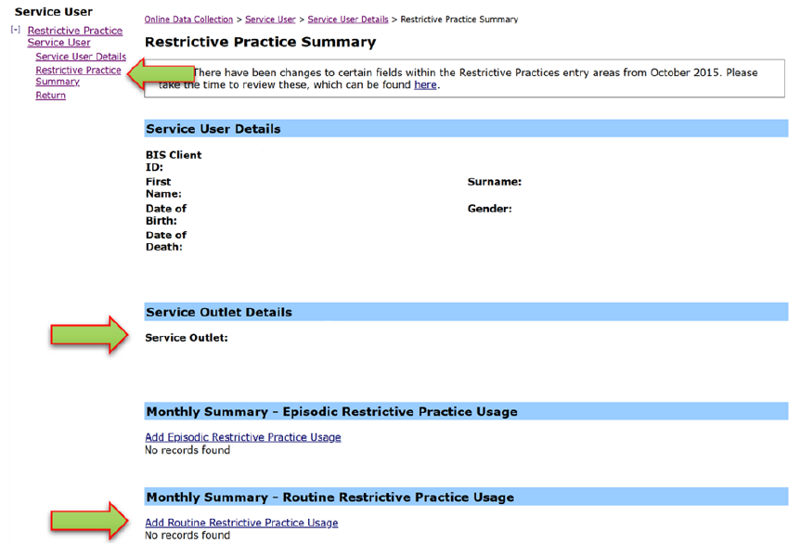

- Select Chemical Restraint Fixed Dose for the Add a new Restrictive Practice type.
- Enter the following details:
- Medication – Select the generic name of the medication from the drop-down list. If not listed, select “Other” from the drop list and provide the details in the adjoining field - If Other, please specify.
- Medication Amount – includes unit of measure
- Medication Frequency – e.g., 1 times per Day
- Prescribed by – the details of the prescribing Doctor
- Start Date – The start date for the date range of usage
- End Date – The end date for the date range of usage
- Behaviour Posing Risk of Harm to Self Or Others – Record this as the main behaviour that was presented and the behaviour led to the use of the Restricted Practice.
- Injury - only required to be entered if an injury was sustained as a result of using the Restrictive Practice.
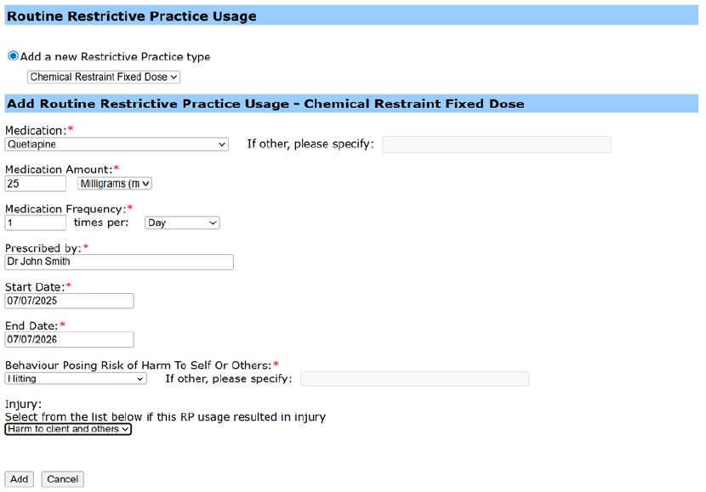
- Select the ‘Add’ button.

An example of Chemical Restraint
Jeremy is 21 years of age and lives with one other man in a rented unit. The two men are
supported to live there by paid staff. Jeremy has been taking a pill for his behaviour for six years. Jeremy has just started to hit and grab staff when they are driving in the car. Staff have thought about what is happening and checked Jeremy’s health and if there are any other problems.
Jeremy’s activity level has been increased, staff now let him know where he is going and why,
and car trips have been shortened. However, there is still a problem. Jeremy needs to travel in
the car to attend regular doctor’s appointments, visit his mother and go to the movies; something he really enjoys. Staff have asked if Jeremy can take something to calm him before he goes for a drive in the car. Jeremy already has a guardian for restrictive practice (general) matter as he has been taking a pill to help him with his behaviour which is a chemical restraint (fixed dose) since he started living in the house when he turned 18 years.

Reporting Episodic Chemical Restraint As Required in ODC
Login to ODC to display the Online Data Collection page:
- Select Restrictive Practice drop down list and select Restrictive Practice Service User hyperlink to display the Search Restrictive Practice Service User page.
- Enter the Service User’s details
- Select ‘Search’ button.
- Select from the search result the Service User’s Surname hyperlink to display the Service Users Details page.
- Select Restrictive Practice Summary from the Service User menu to display the Restricted Practice Summary page.
- Select the Service Outlet where the Restricted Practice occurred.
- Select Add Episodic Restrictive Practice Usage hyperlink.
- Select Chemical Restraint As Required for the Add a new Restrictive Practice type.

Note this example shows no previous recording of Restrictive Practice Usage and this is the first Usage recorded for the Service User and the Service Outlet. This is the only time that Chemical Restraint As Required for the Service User and Service Outlet is to be entered. Every other time an instance of use is added to the existing “Chemical Restraint As Required” Restrictive Practice Type, so that all Usage is reported under the same Restrictive Practice Type. This allows trending of usage so it can be determined if this Restrictive Practice is being eliminated or reduced in Usage.
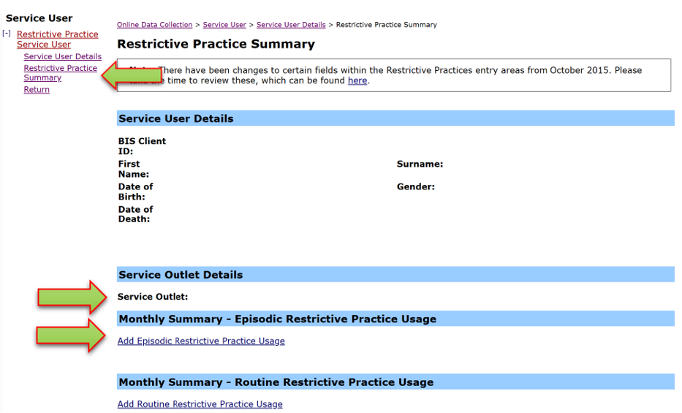
- Enter the following details:
  - Medication – Select the generic name of the medication from the drop-down list. If not listed, select Other from the drop list and provide the details in the adjoining field - If Other, please specify
  - Medication Amount – includes unit of measure
  - Prescribed by – the details of the prescribing Doctor
- Select Add new instance of use hyperlink.
- Enter the following details:
  - Date – The date the medication was administered
  - Time – The time the medication was administered
  - Behaviour Posing Risk of Harm to Self Or Others – Record this as the main behaviour that was presented and the behaviour that led to the use of the Restricted Practice.
  - Injury - Injury is only required to be entered if an injury was sustained as a result of using the Restrictive Practice.
- Select the Save hyperlink.
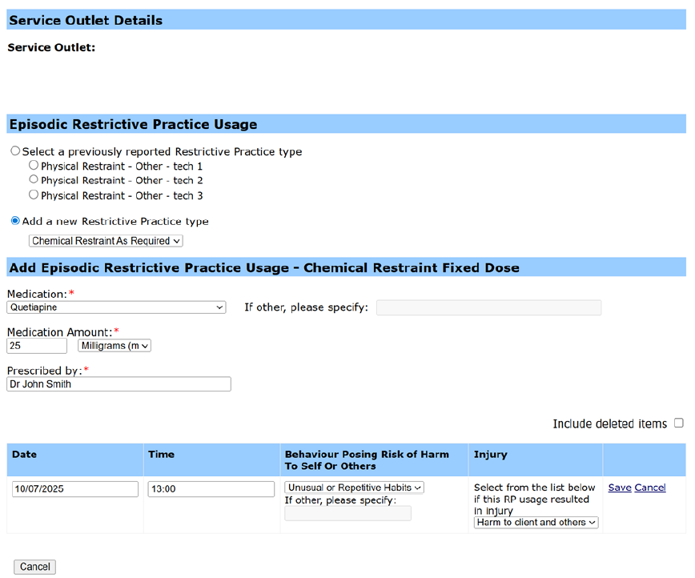

Data Entry Tips
- when entering the date, the year can be shortened to 2 digits. E.g. 13/09/20xx can be entered as 13/9/xx
- when entering the time, no “:” is required to separate the hours and minutes. The time is recorded in 24-hour format. E.g. 09:10AM can be entered as 910, or 1:17PM can be recorded as 1317.

