Department of Families, Seniors, Disability Services and Child Safety
GUIDE: How to notify the department of a Restrictive Practice Approval (Form 6-4)

Search for Restrictive Practice Service User
- Login to the Online Data Collection (ODC) Portal with the provided Data Entry Operator username and password.
- In the left hand menu, click the [+] beside Restrictive Practice.
- Then click on Restrictive Practice Service User.
The Search Restrictive Practice Service User screen is displayed.
- Enter details in the fields available and click on Search.
Note: You do not need to enter all fields to run a search. You can enter either the NDIS ID and/or Surname and/or First Name. 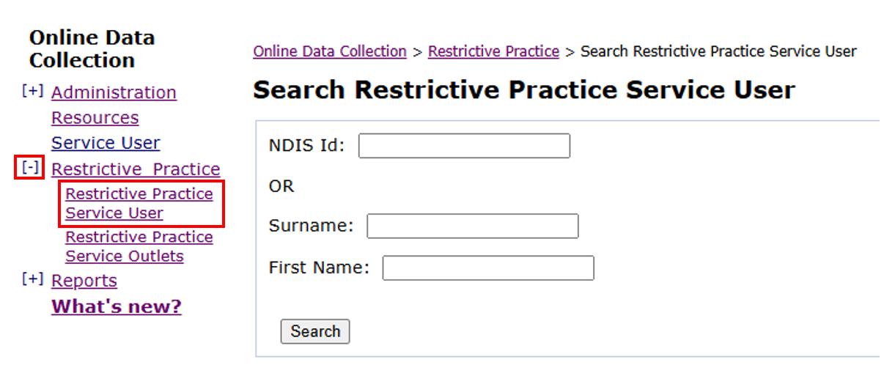
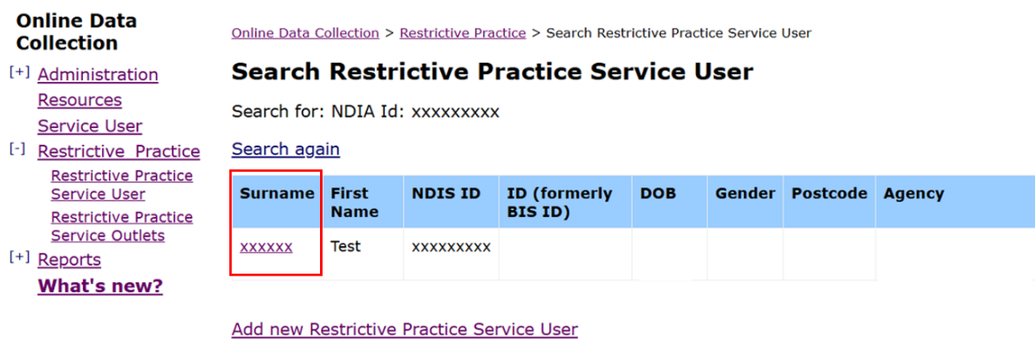
- Click on the service user’s surname to access Service User Details.

Note: if there are no results from your search, the service user is not linked to your organisation. You will need to add the new Restrictive Practice Service User first. Refer to How to create a new Restrictive Practice Service User

Complete Form 6-4
- In the Service User Details section, click on Form 6-4: Notification of Approval or Consent to the Use of Restrictive Practices.
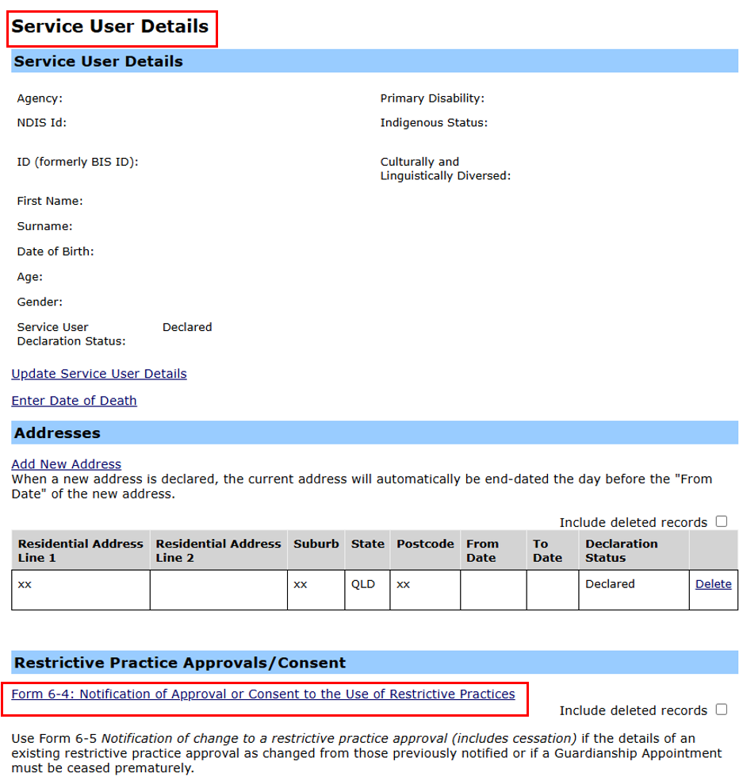
- Complete Approval/Consent details and press Next.
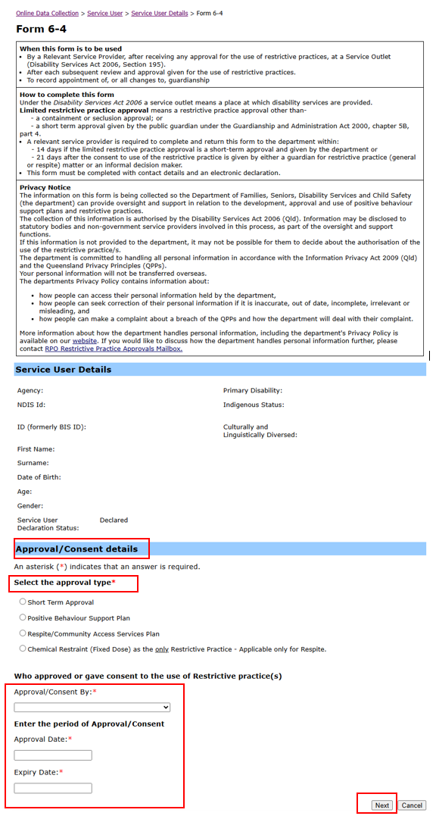

Add approved Restrictive Practices
- You must enter all approved restricted practices listed in the Notice of Decision.
Each restrictive practice must be entered separately and must be consistent with the details of the Notice of Decision.
- To enter the approved restrictive practices, click on Add Restrictive Practice.
- Then choose the Restrictive Practice from the drop down menu.
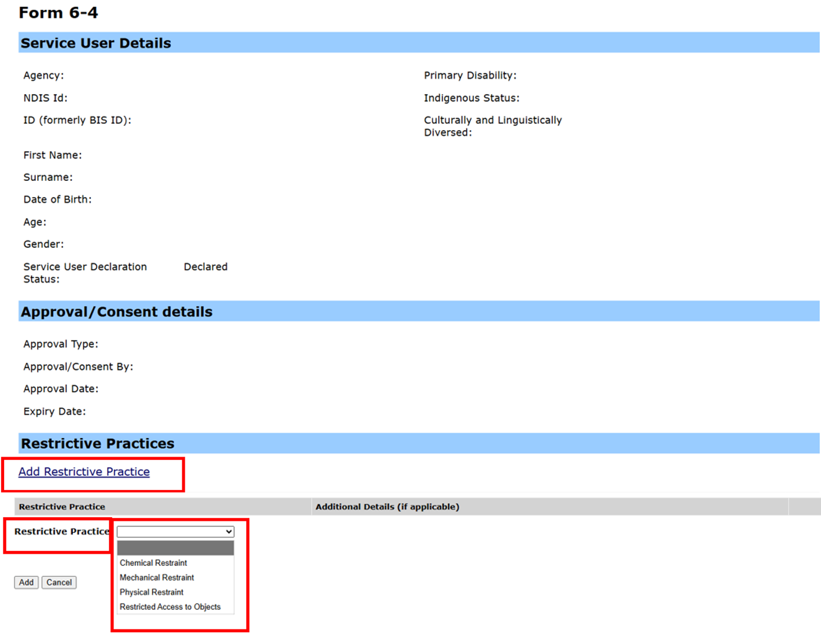

- Select the Type of restraint. If the approved type of restraint is not listed, choose Other and add details in the box provided.
- Once details have been selected/entered, click Add.
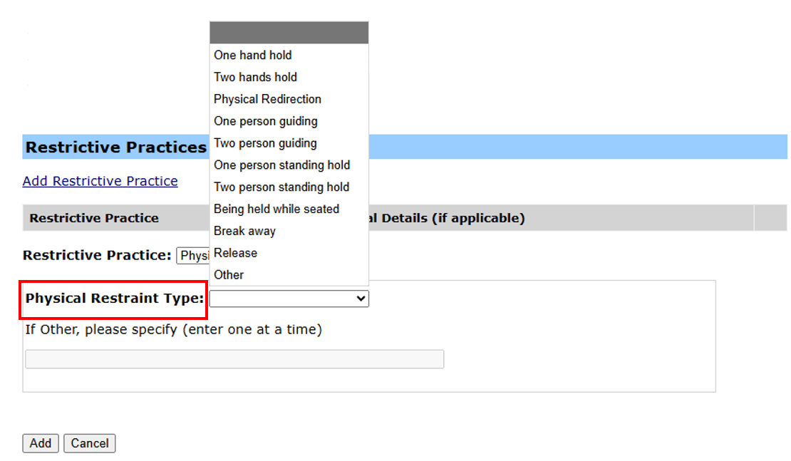

- After all approved restrictive practices have been added, click on the Next button.
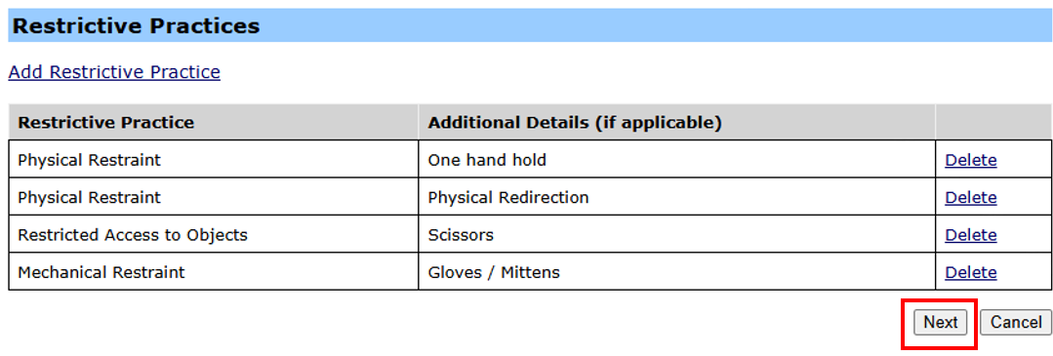

Add Service Outlet
- To create a new service outlet, click on Add new Restrictive Practice Service Outlet.
Complete the details in the popup box for Create a Restrictive Practice Service Outlet and Submit.
- To add Relevant Service Outlet Details to each restrictive practice, select all relevant locations from the Available box.
- To select multiple locations, hold the Ctrl key down on your keyboard while you select multiple locations. Then select Add.
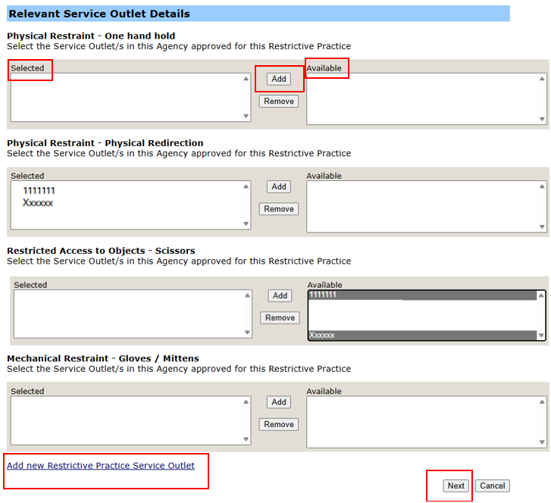

Add Appointment of Guardian
Applicable to Form 6-4: Positive Behaviour Support Plan (PBSP)/ Respite/Community Access Service (CAS) Plan or Chemical Restraint (fixed dose) as the only Restrictive Practice for Respite only.
Enter the Guardian Name, select the Guardian Type and enter the period that QCAT has appointed them (refer to QCAT Notice of Decision).
A Relevant (Informal) Decision Maker can consent to Restricting Access within a PBSP, Physical Restraint and Mechanical Restraint within a Respite/ CAS Plan and Chemical Restraint (fixed dose) within a Respite only plan.
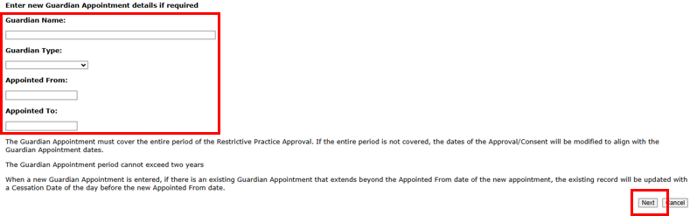
To add details for Appointment of Guardian, refer to How to add guardian details to an existing Restrictive Practice Approval.

Review and Submit Form 6-4
- Review all details that have been entered and ensure they are consistent with the Notice of Decision.
- Once you’re sure all details are correct and consistent, click Submit.
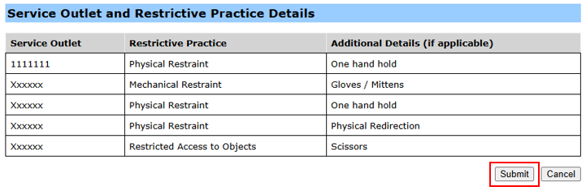
- The Declaration Status of the Form 6-4 (notification) is now Submitted in the Restrictive Practice Approvals/Consent section of the Service User Details.
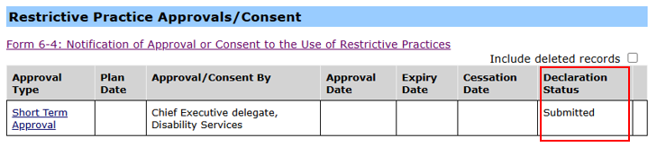
- The Restrictive Practice Approvals/Consent must now be Declared (authorised). A notification will be emailed to the Authorising Agency Officer. To Declare refer to How to authorise a Restrictive Practice declaration.
Note: Implementing providers registered with the NDIS Commission are required to submit monthly reports to the NDIS Commission on the use of restrictive practices against the participant’s current/ active positive behaviour support plan.

