Department of Families, Seniors, Disability Services and Child Safety
GUIDE: How to notify change of details to an existing Restrictive Practice Approval (Form 6-5)

Search for Restrictive Practice Service User
- Login to the Online Data Collection (ODC) Portal with the provided Data Entry Operator username and password.
- In the left hand menu, click the [+] beside Restrictive Practice.
- Then click on Restrictive Practice Service User.
The Search Restrictive Practice Service User screen is displayed.
- Enter details in the fields available and click on Search.
Note: You do not need to enter all fields to run a search. You can enter either the NDIS ID and/or Surname and/or First Name.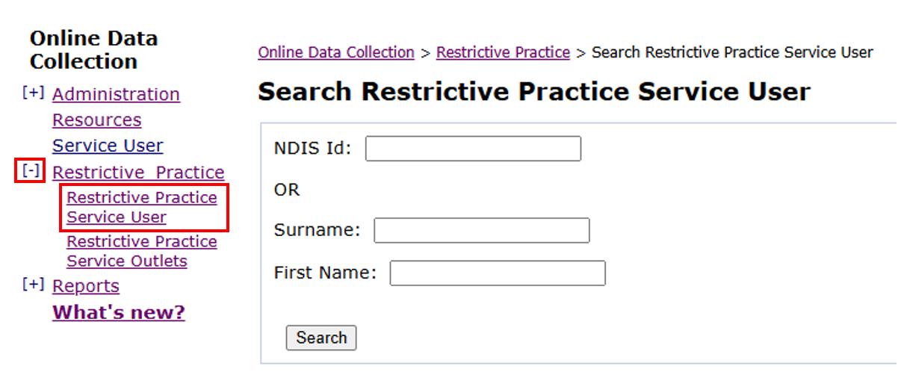
- Click on the service user’s surname to access Service User Details.
- In the Restrictive Practices Approvals/Consent section, select the Form 6-5 link on the right for the approval requiring change or to be ceased.
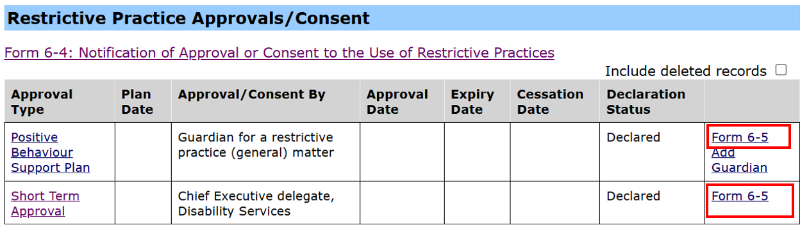
Note: Only the most recent Restrictive Practice Approval record can be changed.

Complete Form 6-5
- The Form 6-5 will be displayed.
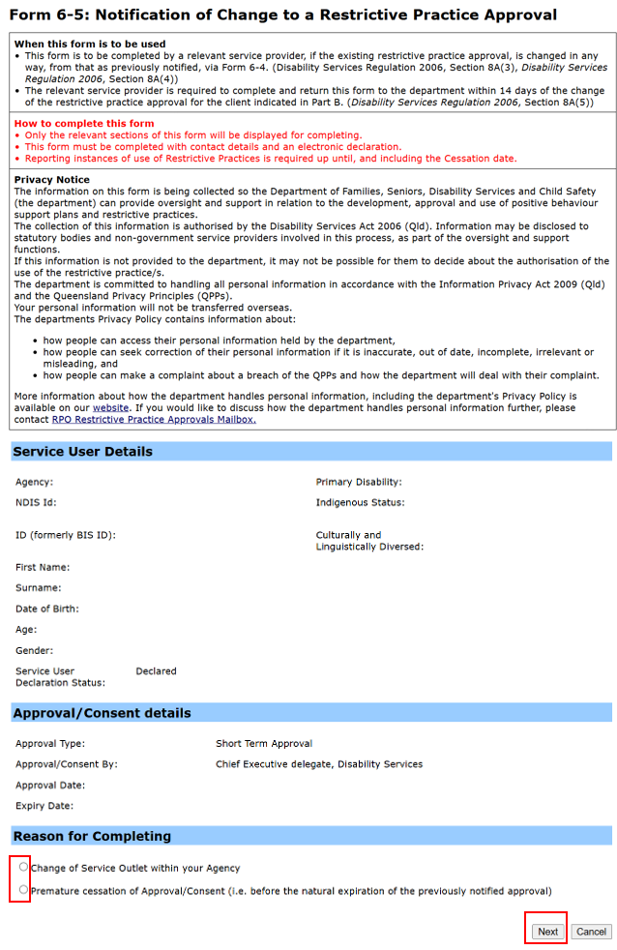
Change of Service Outlet within the Agency:
- Select a Reason for Completing and select Next.
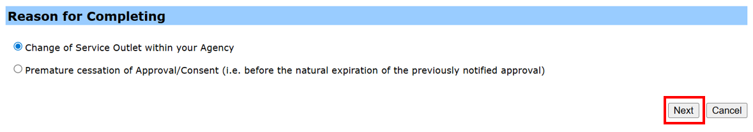
- Enter the Date of Cessation of existing service outlet and the Effective Date at New Service Outlet. The effective date is auto-populated (to today’s date) but can be manually changed.
- Remove the outlet from the Selected box by selecting the outlet and selecting Remove.
- Add the new service outlet from Available box by selecting an outlet and selecting Add. Click Next.
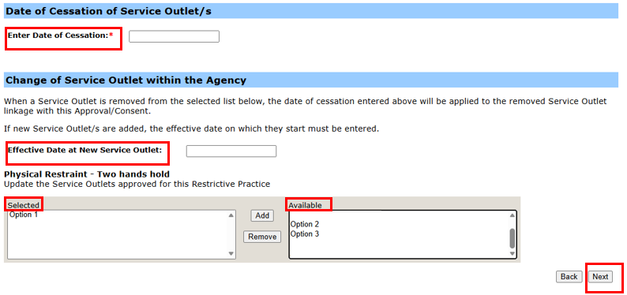
- Review all details to ensure they are correct and then select Submit.
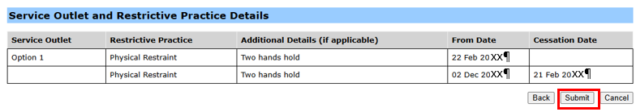
- The Change of Service Outlet (Form 6-5) must now be Declared (authorised). A notification will be emailed to the Authorising Agency Officer. Refer to How to authorise a Restrictive Practice declaration
Premature cessation of Approval/Consent (i.e. before the natural expiration of the previously notified approval):
- Select the Reason for Completing and select Next.
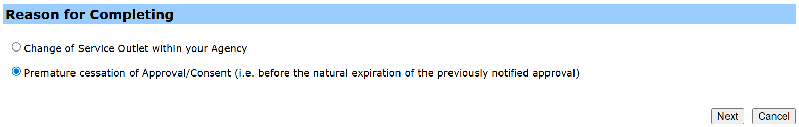
- Enter the Date of Cessation of the existing Approval/Consent details and select Next.
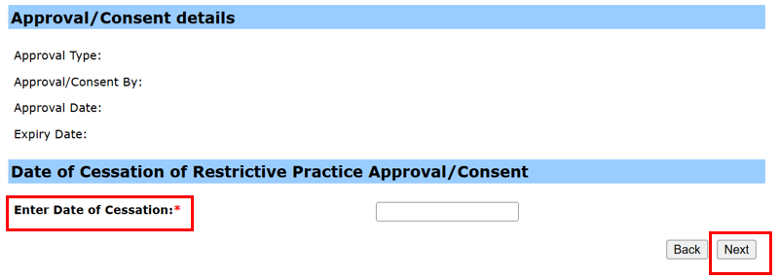
- Review all details to ensure they are correct and then select Submit.
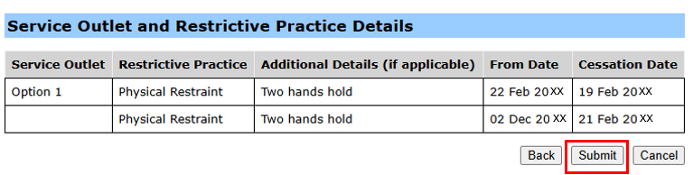
- The Cessation of Approval/Consent (Form 6-5) must now be Declared (authorised). A notification will be emailed to the Authorising Agency Officer. Refer to How to authorise a Restrictive Practice declaration.
Note: Implementing providers registered with the NDIS Commission are required to submit monthly reports to the NDIS Commission on the use of restrictive practices against the participant’s current/ active positive behaviour support plan.

