Department of Families, Seniors, Disability Services and Child Safety
GUIDE: How to create a new Restrictive Practice Service User

Search for Restrictive Practice Service User
- Login to Online Data Collection (ODC) Portal with the provided Data Entry Operator username and password.
- In the left hand menu, click the [+] beside Restrictive Practice.
- Then click on Restrictive Practice Service User.
- Do a search to verify the Service User is not already in ODC. Refer to How to access a Restrictive Practice User.

Add new Restrictive Practice Service User
- If the user is not in ODC, click on Add new Restrictive Practice Service User. (You won’t see the “Add new Restrictive Practice Service User” link until after you have clicked search.)
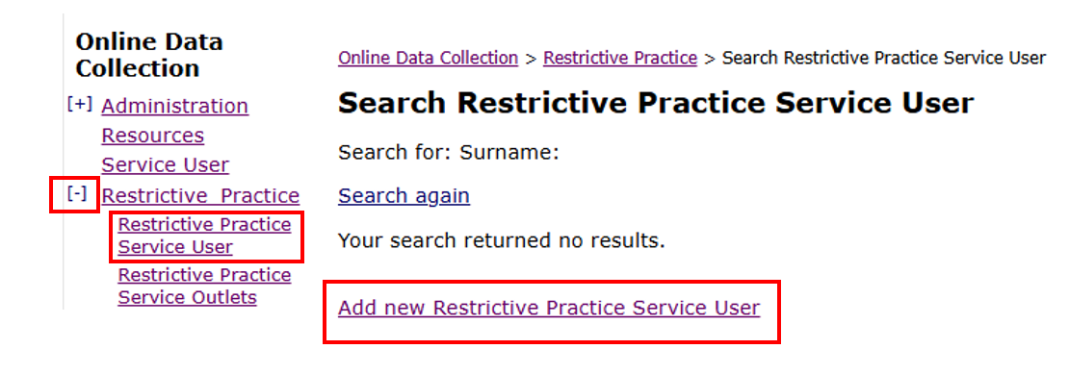
- Add Service User Details and Address Details. Click Submit.
The Service User Details must now be Declared (authorised). A notification will be emailed to the Authorising Agency Officer. To Declare, refer to How to authorise a Restrictive Practice Declaration.
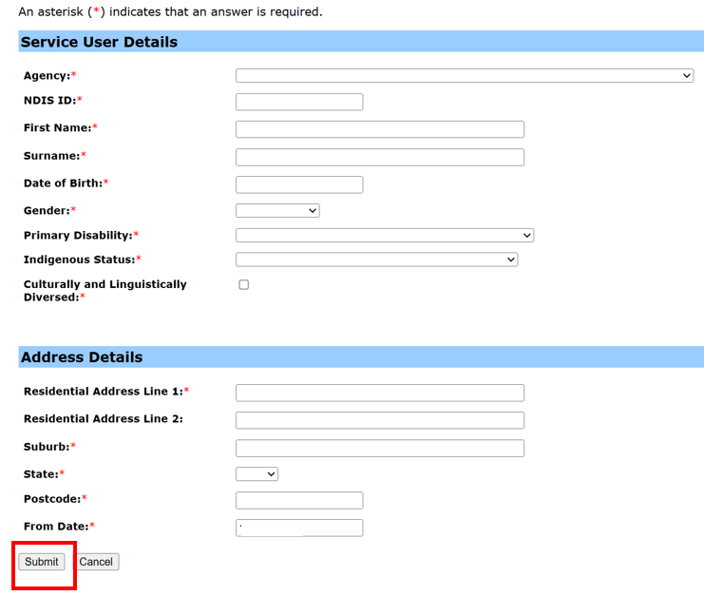
- A new Service User Details section will be created which includes the Service User Details section, Addresses section, and Restrictive Practice Approvals/Consent section.
From the Restrictive Practice Approvals/Consent section at the bottom of your screen, you can notify the department of a Short-Term Restrictive Practice Approval, Positive Behaviour Support Plan, and Guardian for Restrictive Practice by completing the Form 6-4.
Refer to How to notify the department of a Restrictive Practice Approval (Form 6-4) and How to add guardian details to an existing Restrictive Practice Approval
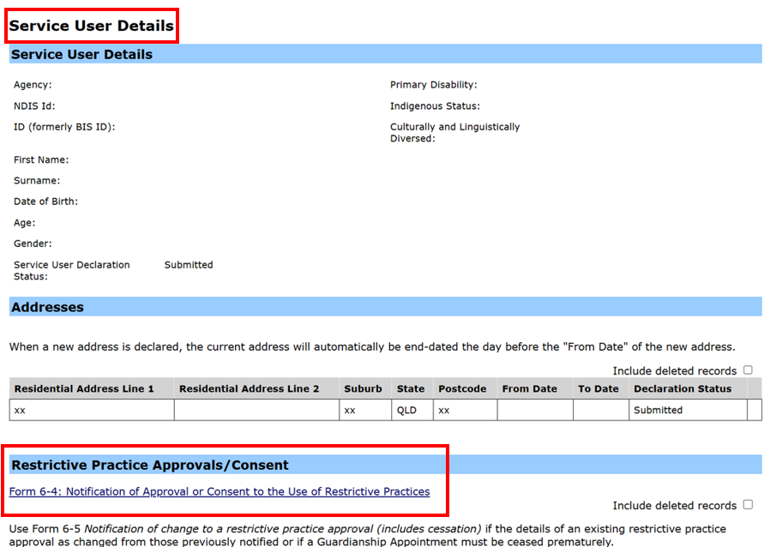

Note: Implementing providers registered with the NDIS Commission are required to report monthly to the NDIS Commission on the use of restrictive practice, against the participant’s current/active Positive Behaviour Support Plan.

