Department of Families, Seniors, Disability Services and Child Safety
GUIDE: How to create a Restrictive Practice Service Outlet

Search for Restrictive Practice Service Outlets
- Login to the Online Data Collection (ODC) Portal with the provided Data Entry Officer (DEO) username and password.
- In the left hand menu, click on the [+] beside Restrictive Practice.
- Click on Restrictive Practice Service Outlets.

Add new Restrictive Practice Service Outlet
- Click on Add new Restrictive Practice Service Outlet.
Note: From this page you can also expire verified service outlets when they are no longer operational. If a service outlet is unverified and requires to be expired, please contact Reporting and Compliance, compliance_rp@qld.gov.au or 1800 902 006 (option 1).
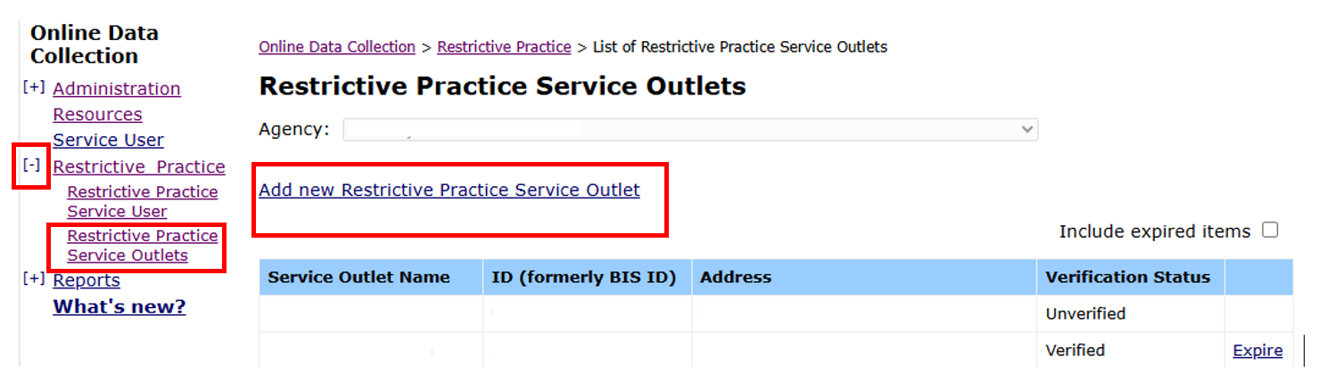

- A pop-up window will be displayed. (If the pop-up box doesn’t appear, update your internet settings to allow pop-ups.)
- Add Restrictive Practice Service Outlet details. Click Submit.
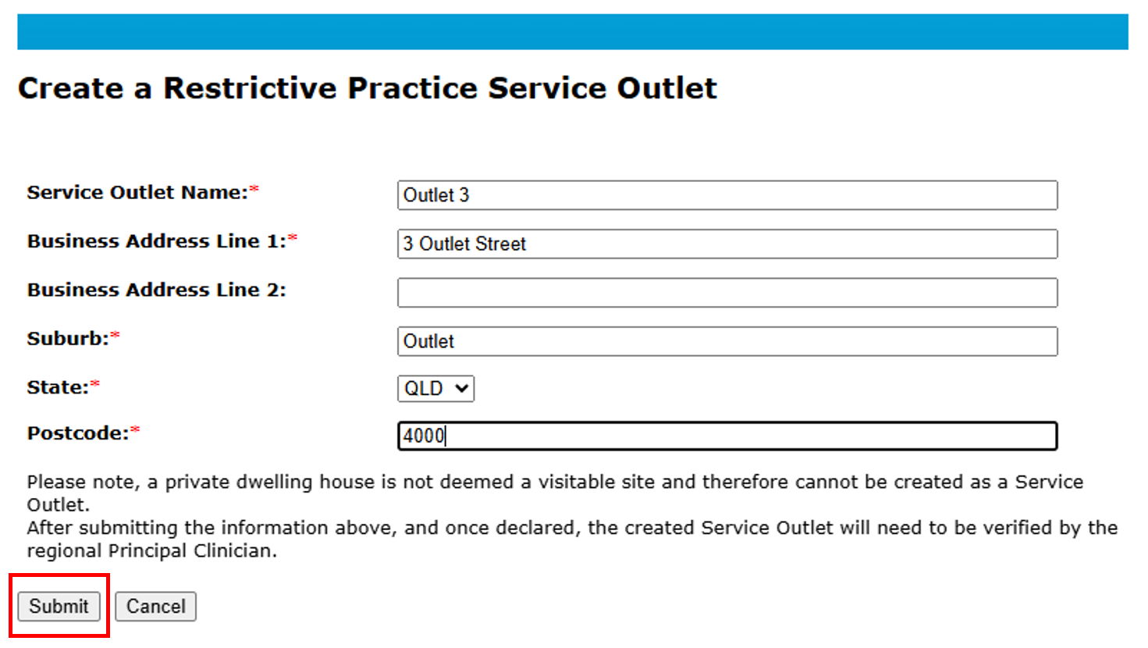
- The Restrictive Practice Service Outlet must now be Declared (authorised). A notification will be emailed to the Authorising Agency Officer. Refer to How to authorise a Restrictive Practice declaration.

Note: Once the new outlet is declared it is sent to the department to verify if the outlet address is appropriate for use for restrictive practices (Only applicable to Disability Support Accommodation Services (DSAS)).
Note: Implementing providers registered with the NDIS Commission are required to submit monthly reports to the NDIS Commission on the use of restrictive practices against the participant’s current/ active positive behaviour support plan.

