Department of Families, Seniors, Disability Services and Child Safety
GUIDE: How to authorise a Restrictive Practice declaration

Identify and Review RP Declarations
- Login to the Online Data Collection (ODC) Portal with the provided Authorising Agency Officer (AAO) username and password.
- In the left hand menu, click on the [+] beside Reports
- Then the [+] beside Restrictive Practices, then Restrictive Practice Declarations.
- Under Declaration Type, click the drop down to identify all Declaration Types to be reviewed.
- From the drop down list, select a Declaration Type for review.
- Click Display to view a list of awaiting declarations.
- Click on the Surname to view the details of each submission showing.
- Review all details and ensure they are accurate, complete and consistent with the details of the Notice of Decision.
- If data is correct, go to How to Declare/Authorise. If data is incorrect or missing, go to How to Reject.
Note: All declaration types with a number beside them need to be reviewed to determine if the information has been entered correctly.
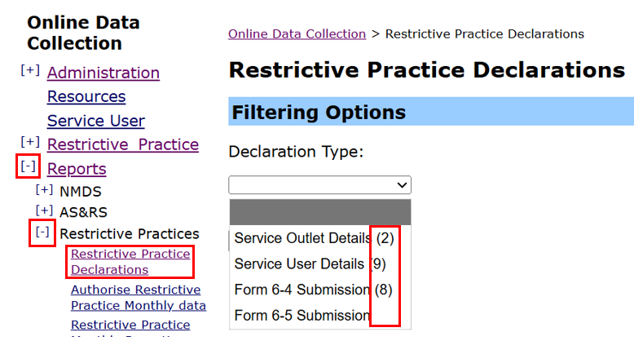

How to Declare/Authorise
Once the data has been reviewed and is correct and complete, Declare as follows:
- Select □ check box to the left of the relevant record.
- Enter details in the mandatory fields under Declaration Details.
- Click on Declare.
- Repeat these steps until all of the correct and complete submissions have been Declared.
- If there is incorrect or missing information in the submission, don’t Declare – See How to Reject.
Note: The number next to each declaration type indicates how many Submissions need to be reviewed and then either Declared (if correct) or Rejected (if incorrect).

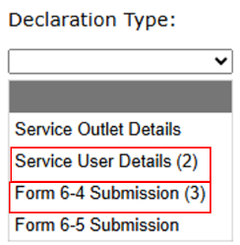

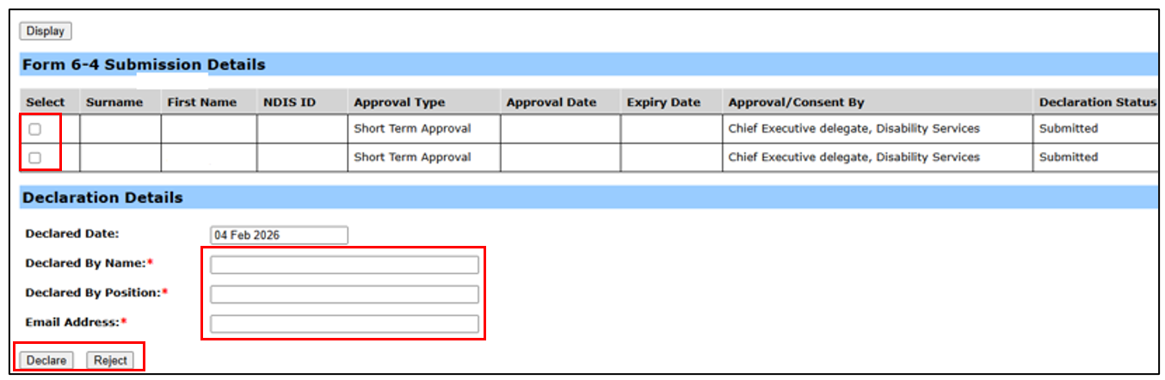

How to Reject
If there is incorrect or missing data, the Form 6-4 will need to be Rejected and then Edited.
- Under Declaration Details, ensure the mandatory fields are completed.
- Click on Reject. Enter the reason for rejecting into the pop-up box, then save.
(If the pop-up box doesn’t appear, update your internet settings to allow pop-ups.)
- A notification will be sent to the user who submitted the form so they can edit and then re-submit.
- To edit, log in as Data Entry Officer and go to Restrictive Practice Approvals/Consent, click on Edit, then make the required changes to the Form 6-4. Once editing is complete, click Submit. Then Declare the edited Form 6-4, see - How to Declare.
- Rejected Form 6-4 records that are not required, for example, a duplicate record, a record created in error, or an unapproved STA etc, should be deleted. Click Delete (on the record that’s not required or created in error).
- If the Service User Details are incorrect, you will need to Declare the Service User Details first. Then login as Data Entry Officer and go to Service User Details, click on Update Service User Details, edit the details, then click submit. You will then need to Declare the updated Service User Details.
Note: You cannot edit Form 6–4 information that has been declared.
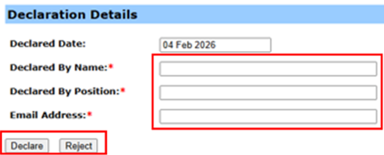
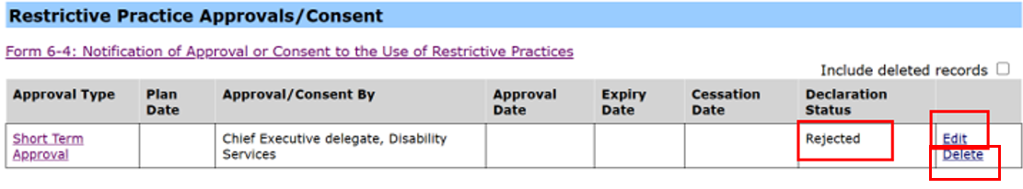
Note: Implementing providers registered with the NDIS Commission are required to submit monthly reports to the NDIS Commission on the use of restrictive practices against the participant’s current/ active positive behaviour support plan.

