Department of Families, Seniors, Disability Services and Child Safety
GUIDE: How to add guardian details to an existing Restrictive Practice Approval

Search for Restrictive Practice Service User
- Login to the Online Data Collection (ODC) Portal with the provided Data Entry Operator username and password.
- In the left hand menu, click the [+] beside Restrictive Practice.
- Then click on Restrictive Practice Service User.
The Search Restrictive Practice Service User screen is displayed.
- Enter details in the fields available and click on Search.
Note: You do not need to enter all fields to run a search. You can enter either the NDIS ID and/or Surname and/or First Name. 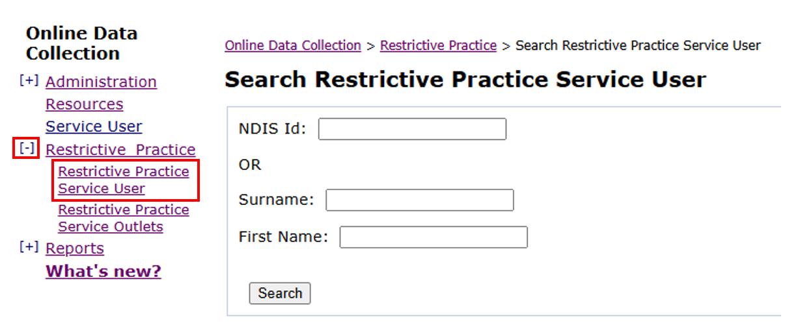
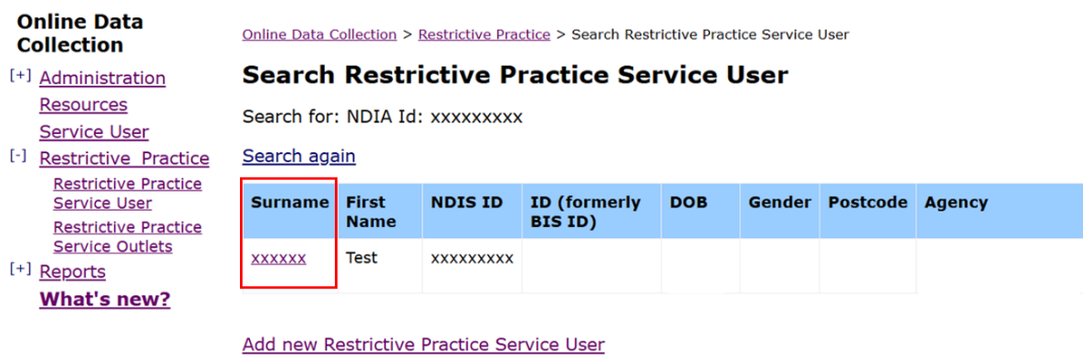
- Click on the service user’s surname to access Service User Details.

Add Guardian Details
- Scroll down to the Restrictive Practice Approvals/Consent section and click on Add Guardian link.
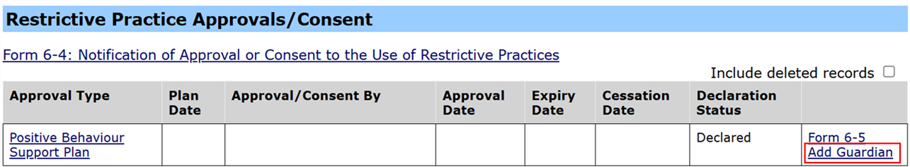
The Expiry Date is the only detail that can be modified. This allows you to edit the Expiry Date on the Form 6-4 under the Approvals/Consent Details box, then click on next.
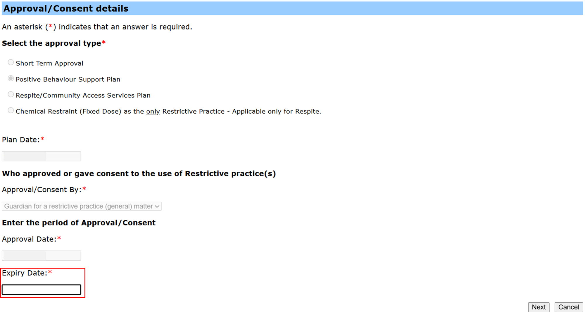
- Enter the new Guardian Appointment details and click on Next.
- The Form 6-4 with the updated details will display. Click on Submit.
An email notification will go to the Authorising Agency Officer to advise that a Form 6-4 submission requires declaring/ authorisation. To Declare, refer to How to authorise a Restrictive Practice Declaration.

Service providers can update guardian appointment details for a Form 6-4 Positive Behaviour Support Plan or Respite/ Community Access Service Plan. When the guardian is not appointed for the entire 12 months of the plan, the PBSP/ Respite/ CAS Plan expiry date can only be entered up to the end date of the guardian’s appointment. When a new guardian is known, you can update the details again.
Note: Implementing providers registered with the NDIS Commission are required to submit monthly reports to the NDIS Commission on the use of restrictive practices against the participant’s current/ active positive behaviour support plan.

