Department of Families, Seniors, Disability Services and Child Safety
GUIDE: How to access Restrictive Practice Service User Details

How to Access Restrictive Practice Service User
- Login to the Online Data Collection (ODC) Portal with the provided Data Entry Officer (DEO) username and password.
- In the left hand menu, click the [+] beside Restrictive Practice.
- Then click on Restrictive Practice Service User.
The Search Restrictive Practice Service User screen is displayed.
- Enter details in the fields available, then click on Search.
Note: You do not need to enter all fields to run a search. You can enter either the NDIS ID and/or Surname and/or First Name.
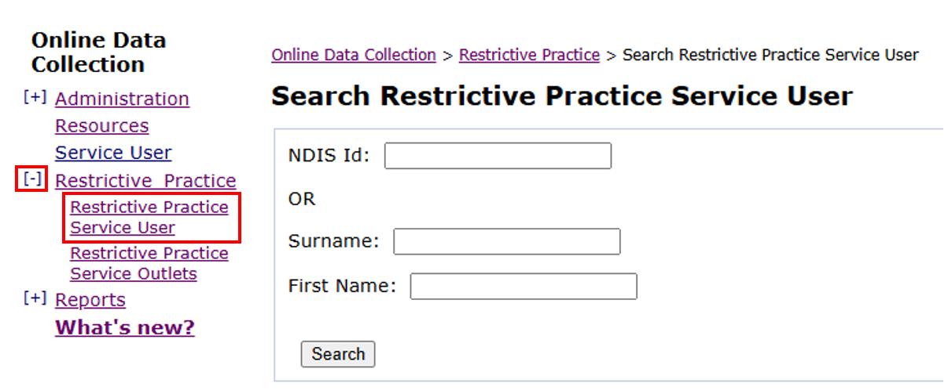

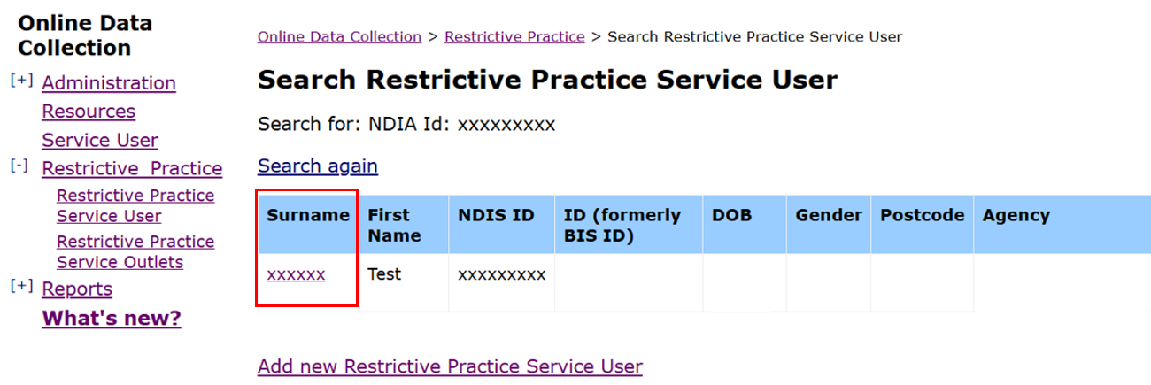
- Your search result will appear as follows.

Note: if there are no results from your search, the service user is not linked to your organisation.
You will need to add the new Restrictive Practice Service User. Refer to How to create a new Restrictive Practice Service User

How to View Service User Details
- To view details, click on the Service Users Surname. From here, you can view the following:
- Service User Details
- Service User Address
- Short Term use of Restrictive Practice - Approvals or Consents, Positive Behaviour Support Plans and Guardianship Appointment History

Available Actions from this Section
- From this section, you can action the following:
- Update Service User Details
- Enter Date of Death
- Add and delete service user Address
- Notify of Approval or Consent to the Use of Restrictive Practices (complete Form 6-4).
Refer to How to notify the department of a Restrictive Practice Approval (Form 6-4)
- Notify of cessation or change to an existing RPA (complete Form 6-5).
Refer to How to notify change of details to an existing Restrictive Practice Approval (Form 6-5)
- Add Guardian details for an existing RPA/or Positive Behaviour Support Plan (PBSP).
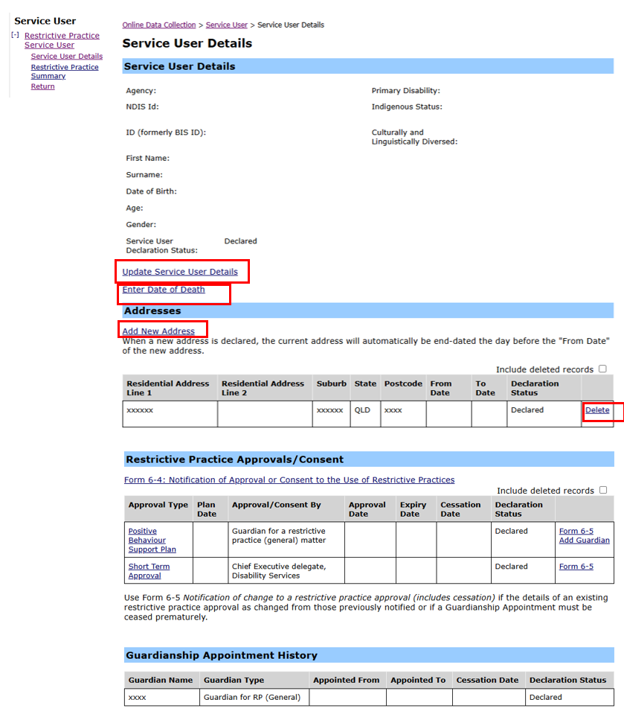
Refer to How to add guardian details to an existing Restrictive Practice Approval

Note: Implementing providers registered with the NDIS Commission are required to report monthly to the NDIS Commission, on the use of restrictive practice.

