Department of Families, Seniors, Disability Services and Child Safety
Completing Service User / Client Data
Required to be completed for all service users receiving services within the month.

Entering Service User Data
- Select “Service User”
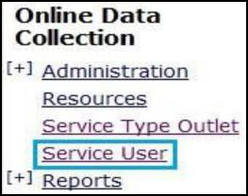
- Enter in search criteria OR Type “0” in the first “BIS Client ID:” box to return all clients
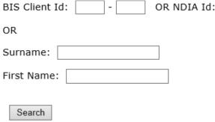
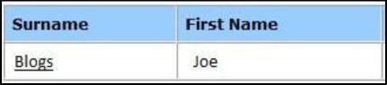
- Select the clients Surname. (This will display the Service User Details)

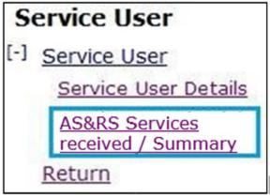
- Select “AS&RS Services received / Summary”

- Select “Add service received details”
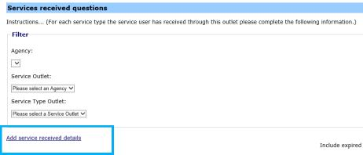
- Complete relevant sections for the service user/client. NOTE: For further details on calculating hours of service refer to the table on page 2.
- Click “Save” after each individual instance of service (this will update the total number of hours received)
- Click “Add” after completing each service user’s record of services received.
- Authorise client data. (See “Authorising client data” for instructions). All selections that can be made from the left side panel, also can be made from the centre section. There is no difference between these fields. NOTE: Please ensure you review all Service User Details. Any updates that are required, please email: ProviderReporting@communities.qld.gov.au

Entering service dates and calculating hours of service
Topic | Information | Example
Accommodation Support | - Enter the date range accommodation services were received  - Each day of service is calculated as 24 hours  - Do not include additional hours e.g. DSTL hours, DSSO hours, double up support  If an individual commences or leaves the accommodation service during the month enter the actual date the person commenced or left the service and calculate the number of days accordingly. | - Service received for the full month start date 1 January 2020 and date 31 January 2020  - Hours of service: 31 days at 24 hours per day = 744 hours  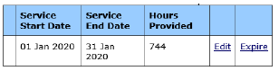
Respite Services | - Each instance of stay in the respite centre must be entered separately  - Each night of service is calculated as 24 hours, this is regardless of actual arrival and departure time  - Do not deduct any hours the individual is away from AS&RS support e.g. school, work, external Community Access agency support  The purpose of this is ensure AS&RS can report to the  National Disability Insurance Agency the number of nights of service that have been provided to an individual during the month. | 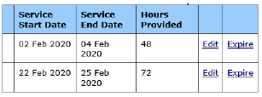
Respite Services | - If a client finishes their stay on the 1st day of the month their full stay will have been calculated in the previous month.  For example: 29th January 2020 to 1st February 2020 will be noted as 29th Jan to 31st January (72 hours) in January ODC data and 1st February to 1st February (12 hours) to show less than full day of service. | 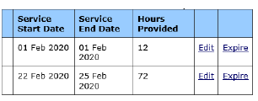
Respite Services | - If a person arrives on the last day of the month the night is recorded as 24 hours.  - The balance of their stay will be recorded in the following month | 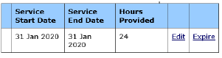

Authorising Client Data
- Select “Reports”
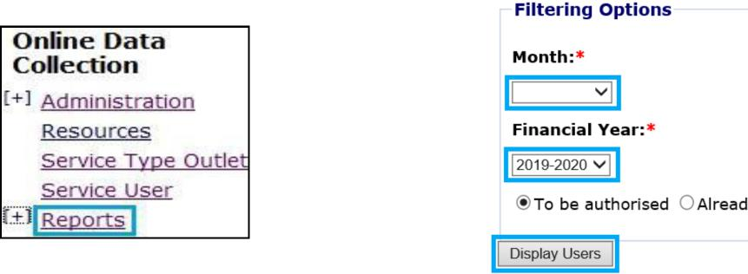
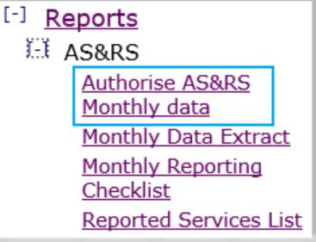
- Select “Authorise AS&RS monthly data”

- Select relevant Quarter/Financial Year and then select “Display Users”

- Review the details entered and either individually select client(s) or select “Select All”.
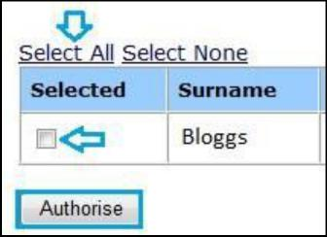
- Click “Authorise” button
TIP: All selections that can be made from the left side panel, also can be made from the centre of the screen section. There is no difference between these fields.

