Department of Families, Seniors, Disability Services and Child Safety
User Guide
Authorisation of Restrictive Practice Information using Online Data Collection (ODC)

Reference Guide to Authorising Restrictive Practice Usage Information in ODC.
This is a guide to common operations in ODC for Authorising Restrictive Practice Information for a Service User, Service Outlet and Reporting Month.

Table of Contents

1. About this Package 3
Authorising Officer Access in ODC 3
Monthly Reporting Timeline 3
Help Available 3
Notify the Department of Changes to the Service User Details 4
2. Main Menu 5
Service User 5
Reports 5
Bulk Imports 6
3. Restrictive Practice Monthly Reporting Checklist 7
Display Restricted Practice Monthly Reporting Checklist for a Reporting Year/Month 7
4. Authorise Restrictive Practice Monthly Data 10
Display Restricted Practice Usage Information Recorded for the Reporting Year/Month 11
Reporting Status 13
Draft 13
Not Reported 13
Selecting Service User’s Restrictive Practice Information to be Authorised 14
5. Unauthorise Restrictive Practice Monthly Data 16
Display Restricted Practice Usage Information Recorded for the Reporting Year/Month 16
Reporting Status 18
Reported 18
Service User’s Restrictive Practice Information to be Unauthorised 18

About this Package
Organisations are required to report the use of Restrictive Practice that occurred during the month to the Department. The reporting of usage can occur any time during the month, or once the end of the month has been reached.
Once the data entry of the Restrictive Practice Usage information has occurred for a Service User and Service Outlet, this information is to be “authorised”. The authorisation step
indicates that Restrictive Practice Usage submission is complete for Service Outlet, Service User and reporting month.
The authorisation sets the reporting status for a Service User and Service Outlet for the month. This authorisation step is needed to:
- Identify whether all usage been reported for a Service User and Service Outlet for the month.
- Differentiate between a Service User with no Restrictive Practice Usage in the month vs unknown usage due to non-reporting.
The authorisation process will allow for multiple Service Users to be authorised, irrespective of whether usage was reported through the online ODC screens or through the bulk upload functionality in ODC.

Authorising Officer Access in ODC
The process of Authorising is to be undertaken by an Officer with the access of Authorising Agency Officer role for that Organisation.

Monthly Reporting Timeline
The relevant Service Provider must give the information to the Chief Executive—
- on the second Friday of the calendar month immediately after the calendar month in which the restrictive practice is used; and
- at other times if the Chief Executive, by written notice, requires the relevant service provider to do so.

Help Available
Publications and Resources:
Resources | Department of Families, Seniors, Disability Services and Child Safety OR Online Data Collection Help
Email help: enquiries_rp@qld.gov.au
Phone help: 1800 902 006*
* Calls from mobile phones are charged at applicable rates.

Notify the Department of Changes to the Service User Details
Email: compliance_rp@qld.gov.au

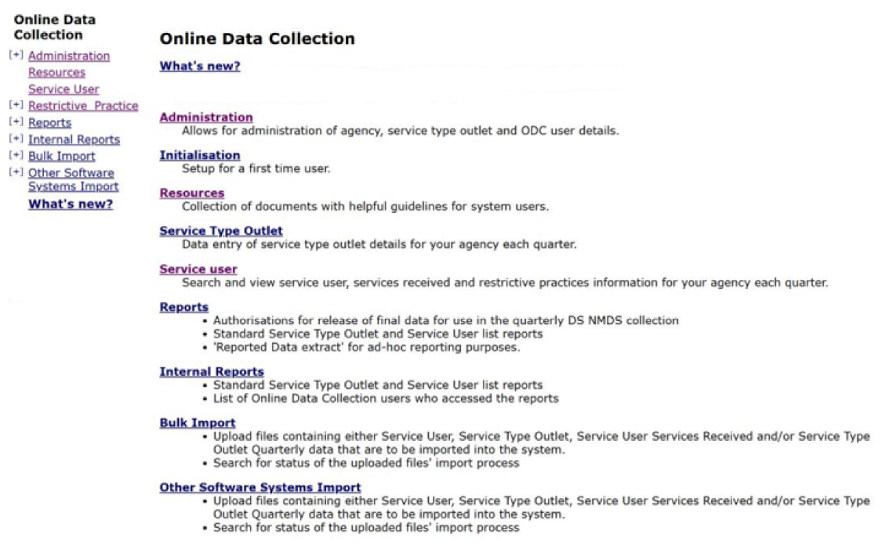
Main Menu
On the main menu on the Online Data Collection page the three sub-menus utilised for Restrictive Practice information are:

Service User
- Search and view Service User.
- Record and view Restrictive Practice information for a Service User.

Reports
- Authorisation for release of final data for use in the monthly Restrictive Practice collection.
- Links for:
  - Restrictive Practice Monthly Reporting Checklist;
  - Restrictive Practice Compliance Report;
  - Restrictive Practice Usage Report;
  - Client Record of Restrictive Practice Usage.

Bulk Imports
- Upload files containing Service User’s Restrictive Practice Usage for import into ODC.
- Organisations with a large number of clients may use the Bulk Import functionality to assist in the data entry of Restrictive Practice Usage information. Search the status of an uploaded file.

Restrictive Practice Monthly Reporting Checklist
The Monthly Reporting Checklist will provide an overview of the reporting status for each
Service Outlet. Utilise the Monthly Reporting Checklist prior to Authorisation as the summary
will indicate:
- Service Outlets with nothing more to do – i.e. no reporting is expected, or alternatively reporting has been finalised for each Service User associated with the Service Outlet.
- Service Outlets that have Service Users that have not yet been authorised. The system will prompt the user to authorise the Restrictive Practice Usage information.
- Service Outlets that have Service Users that were expected to report but have not yet reported. The system will prompt the user to enter the Restrictive Practice Usage information

Display Restricted Practice Monthly Reporting Checklist for a Reporting Year/Month
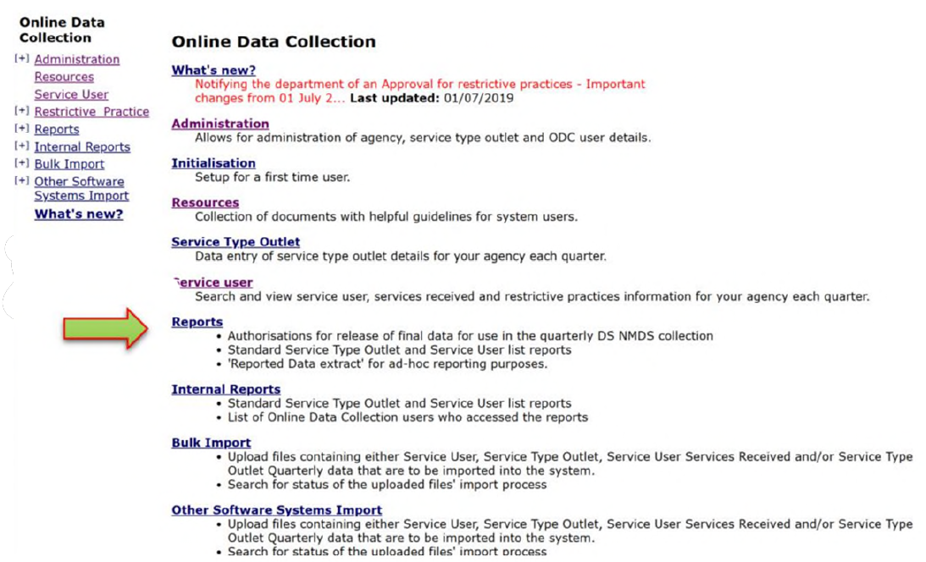
From the Online Data Collection page:
- Select Reports hyperlink from the Main Menu, to display the Reports page.
- Select Restrictive Practice Monthly Reporting Checklist display the Restrictive Practice Monthly Reporting Checklist page.
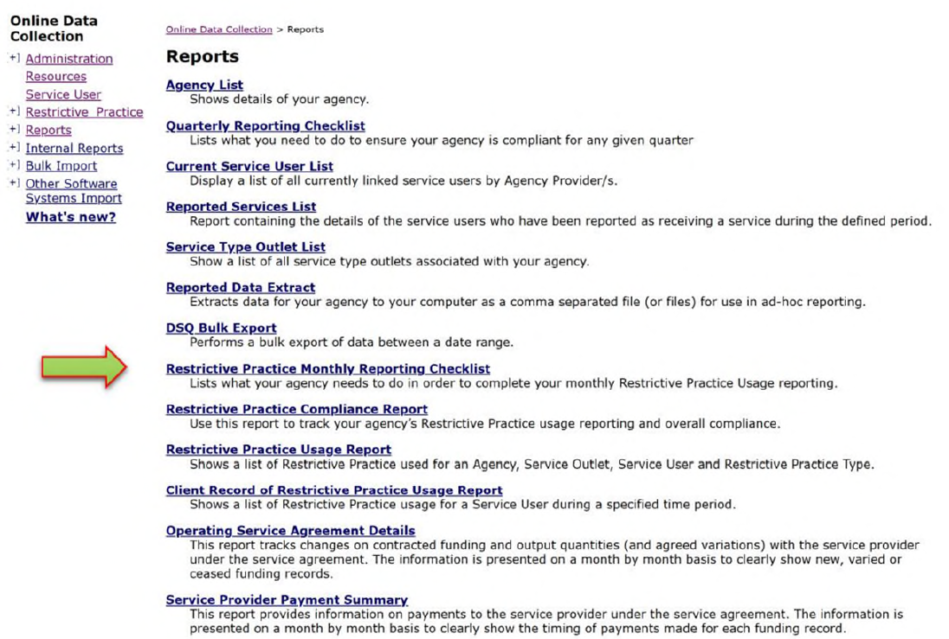
Monthly reporting checklist information will only be displayed for the Service Outlets that user has security access to view. The screen is used to review a summary of the monthly reporting for a selected Agency and one or more Service Outlets associated with the
selected Agency.
- Based on the User’s security profile the Agency List will either be:
  - Disabled and defaulted with the Agency that has been defined for the user.
  - Enabled with no default, to allow the user to select an Agency for review.

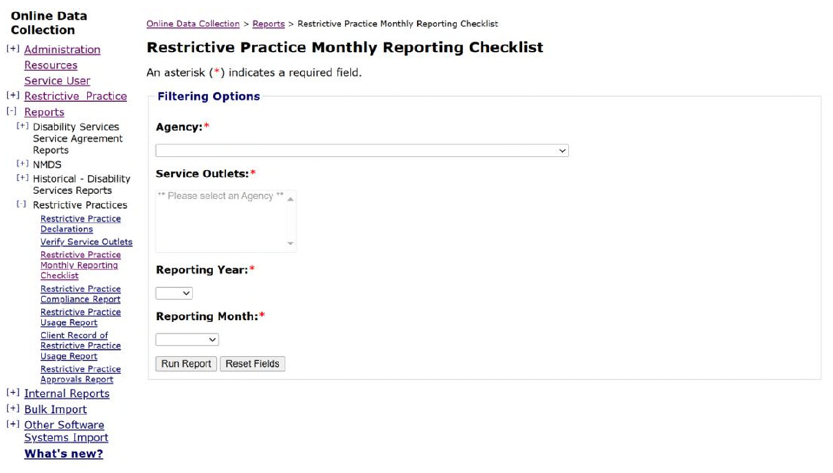
Service Outlets will display once the Agency List populates (dependent on User security access).
Tip:
- Highlight more than one Agency by using the SHIFT or CTRL keys when selecting. Using CTRL allows selection of non-consecutive Service Outlets in the list and using the SHIFT key allows selection of consecutive Service Outlets in the list.
- Select from the drop list the following information:
  - Reporting year
  - Reporting month
- Select Run Report.
The Restrictive Practice Monthly Reporting Checklist Report results are displayed. The example below shows a sample of different results. Use the click here hyperlink to navigate to resolve any outstanding detailed actions.

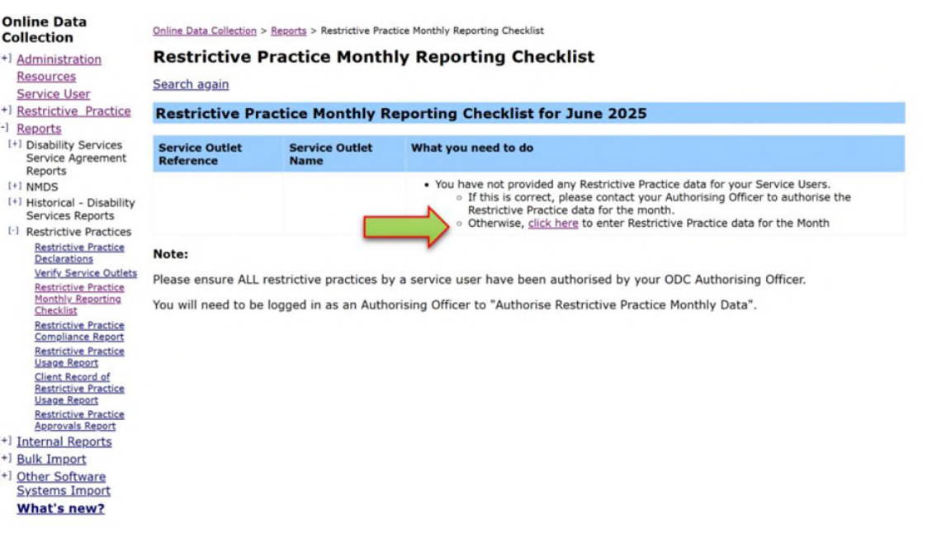
4. Authorise Restrictive Practice Monthly Data
The Officer responsible for Restrictive Practice Usage reporting in an organisation
undertakes the authorising process to confirm and finalise the Restrictive Practice Usage reporting for the month.
Officers will only be able to authorise Restrictive Practice Usage information for Service Users that are associated with a Service Outlet that the Officer has security access to.
Service Users will not be included in the list to Authorise when:
- Restrictive Practice Reporting is not applicable for the Service User. This is identified when:
  - Service User does not have any Restrictive Practice Approvals for the Service Outlet for the reporting month.
  - Service User has no active Restrictive Practice Usage records for the month.
- Restrictive Practice Reporting has already been authorised for the Service User. This is identified when the Service User has a reporting status of Reported for the Service Outlet and reporting month.

Display Restricted Practice Usage Information Recorded for the Reporting Year/Month
From the Online Data Collection page:
- Select Reports hyperlink from the Main Menu, to display the Reports page.
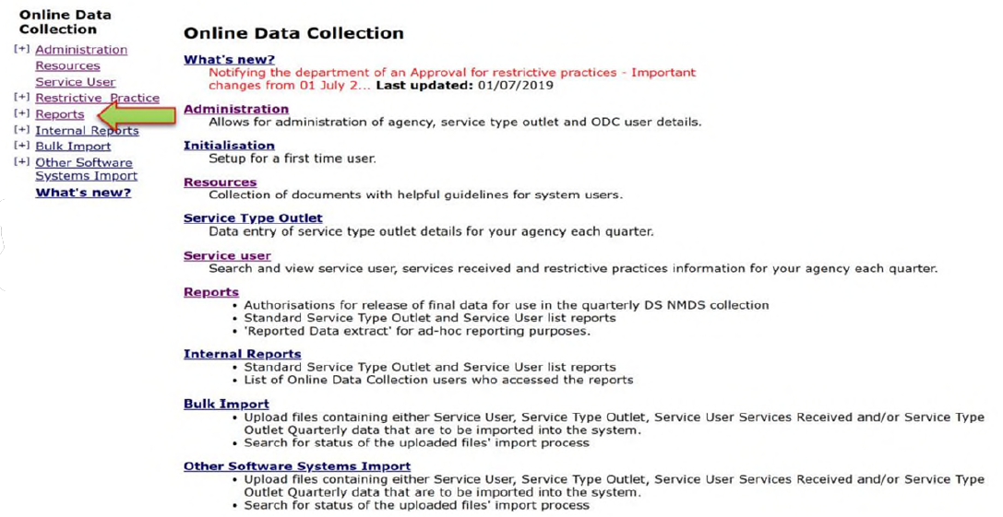

- Select Authorise Restrictive Practice Monthly Data hyperlink on the Reports page to display the Authorise Restrictive Practice Monthly Data page.
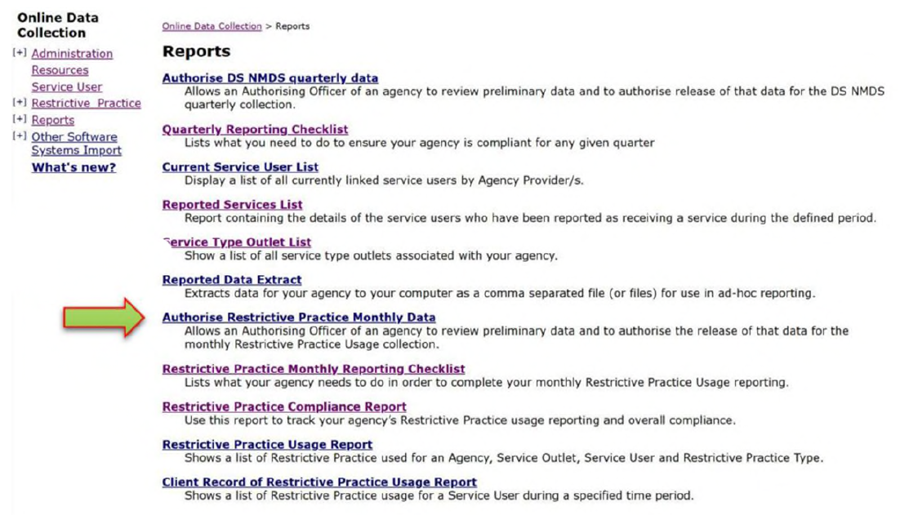
- Select from the drop list the following information:
- Reporting Year
- Reporting Month
- Select ‘To be authorised’.
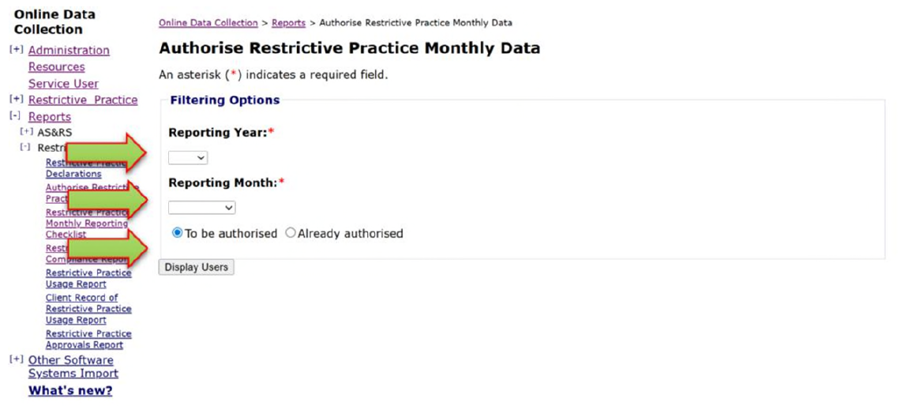
- Select ‘Display Service Users’ button to display the Authorise Restrictive Practice Monthly Data page with the Service User Restrictive Practice Details, see following result example.
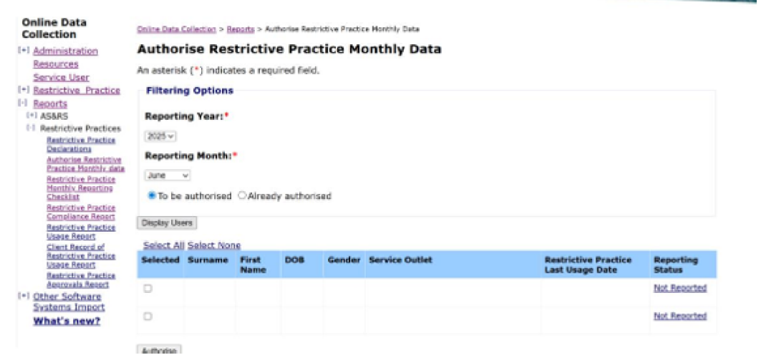

Reporting Status
On the Authorise Restrictive Practice Monthly Data page included in the Service User
Restrictive Practice Details the result returned may display the following Reporting Status:

Draft
A Service User is determined as having a Draft reporting status for the Service Outlet, Reporting Year and Month where:
- At least one restrictive practice usage was recorded and exists with an “Active” (non-deleted) status for the reporting month.

Not Reported
A Service User is determined as having a Not Reported status for the Service Outlet, Reporting Year and Month where:
- There is an Approval for restrictive practice usage, however there are no active restrictive practice usage records exist for the reporting month.

Selecting Service User’s Restrictive Practice Information to be Authorised
- Select individual Service Users by ticking the checkbox beside the Service User’s surname. (Unselect Service Users by ticking the checkbox to remove the tick.)
- Select the ‘Authorise’ button.
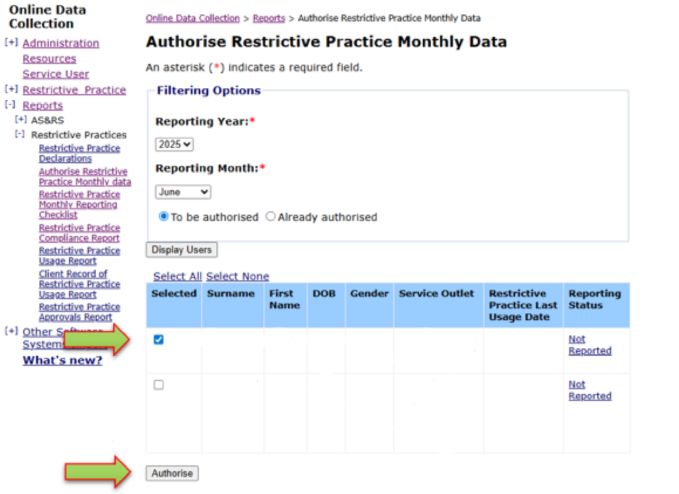
Tip:
- Use the Select All hyperlink to select all Service Users listed under the Service User Restrictive Practice Details in one step.
- Use the Select None hyperlink to deselect all selected Service Users listed under the Service User Restrictive Practice Details in one step.
- Selecting the Draft and Not Reported hyperlink will display the Restrictive Practice Summary screen for the selected Service User and Service Outlet.
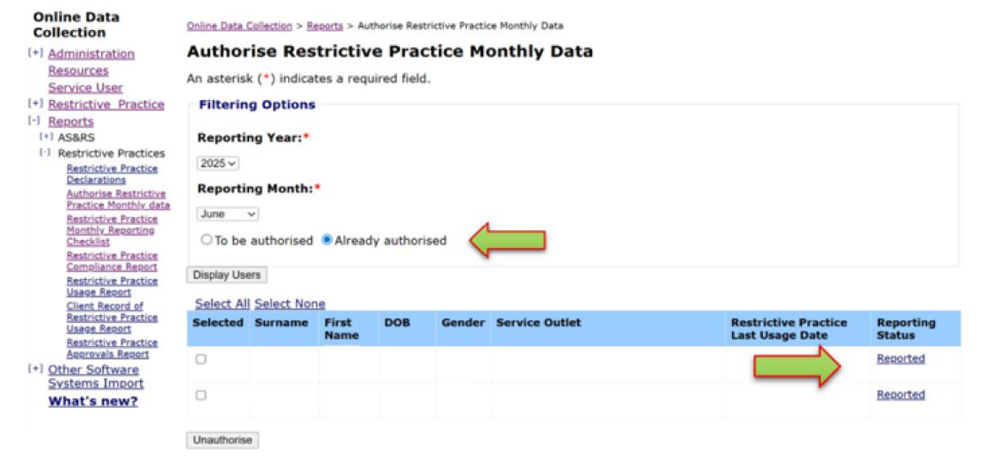
NOTE: Once the records have been Authorised the Authorise Restrictive Practice Monthly Data page displays a Reported hyperlink under the Reporting Status, a bullet point against Already authorised and an active ‘Unauthorise’ button.
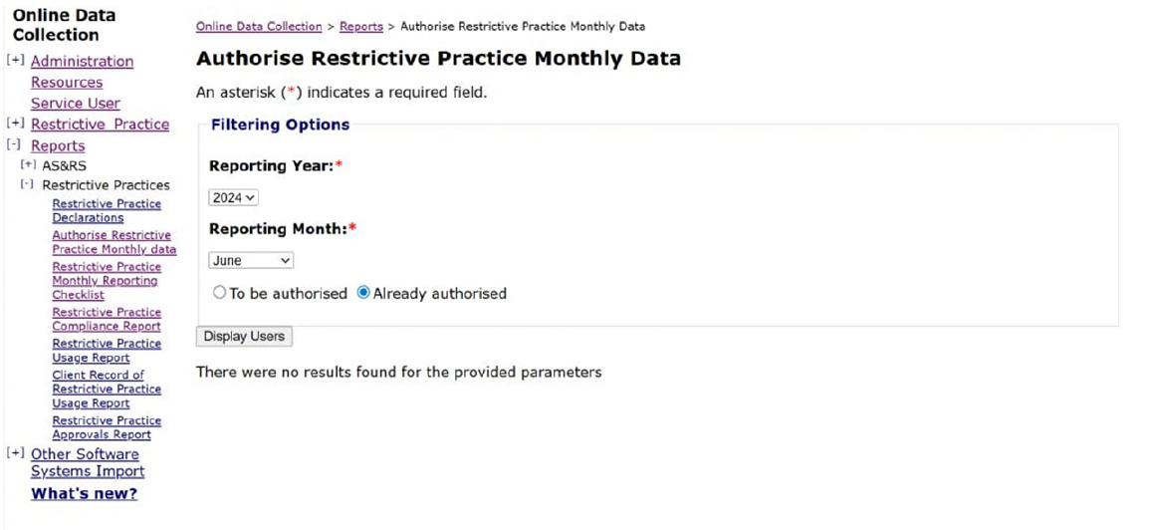
Where a Reporting Year, Month, To be authorised have been selected and the ‘Display Users’ button returns ‘There were no results found for the provided parameters’, there are no approved Service Users that match the Filtering Options.

5. Unauthorise Restrictive Practice Monthly Data
Once authorised, the records for a Service User, at a service outlet, for a month are locked. This means that no entries can be made or deleted, without the records first being unauthorised.
Officers will only be able to Unauthorise Restrictive Practice Usage information for Service Users that are associated with a Service Outlet that the Officer has security access to.
Service Users will not be included in the list to Unauthorise when:
- Restrictive Practice Reporting is not applicable for the Service User. This is identified when:
  - Service User does not have any Restrictive Practice Approvals for the Service Outlet for the reporting month.
  - Service User has no active Restrictive Practice Usage records for the month.
- Restrictive Practice Reporting has not already been authorised for the Service User. This is identified when the Service User has a reporting status of Not Reported or Draft for the Service Outlet and reporting month.

Display Restricted Practice Usage Information Recorded for the Reporting Year/Month
From the Online Data Collection page:
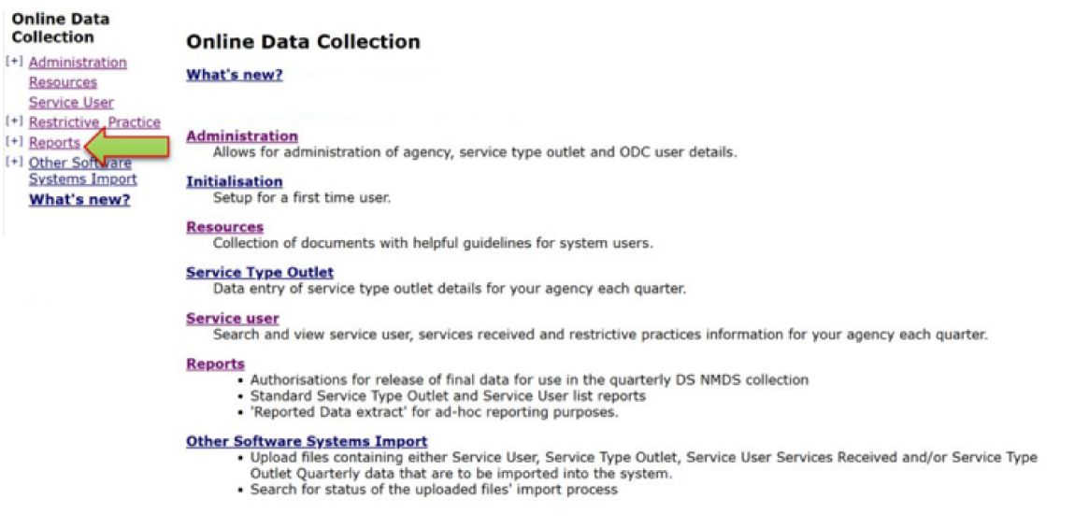
- Select Reports hyperlink from the Main Menu, to display the Reports page.
- Authorise Restrictive Practice Monthly Data hyperlink on the Reports page to display the Authorise Restrictive Practice Monthly Data page.
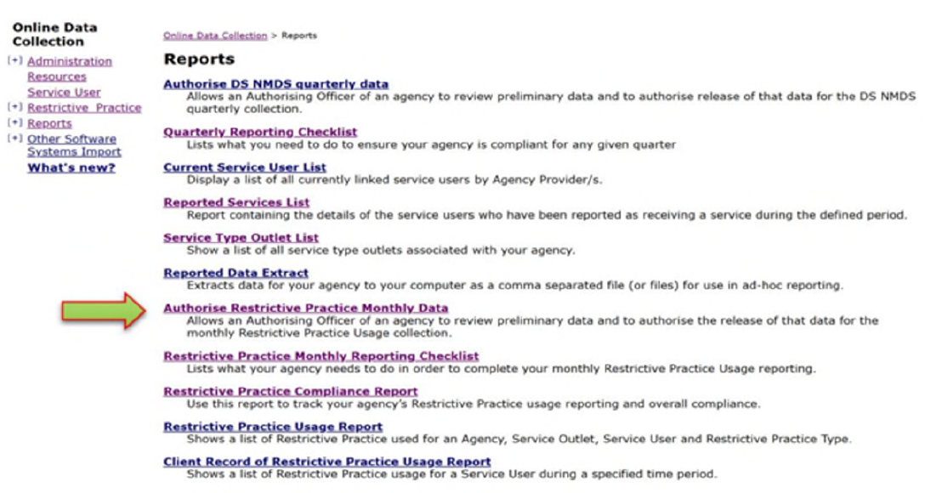
- Select from the drop list the following information:
- Reporting Year
- Reporting Month
- Select Already authorised.
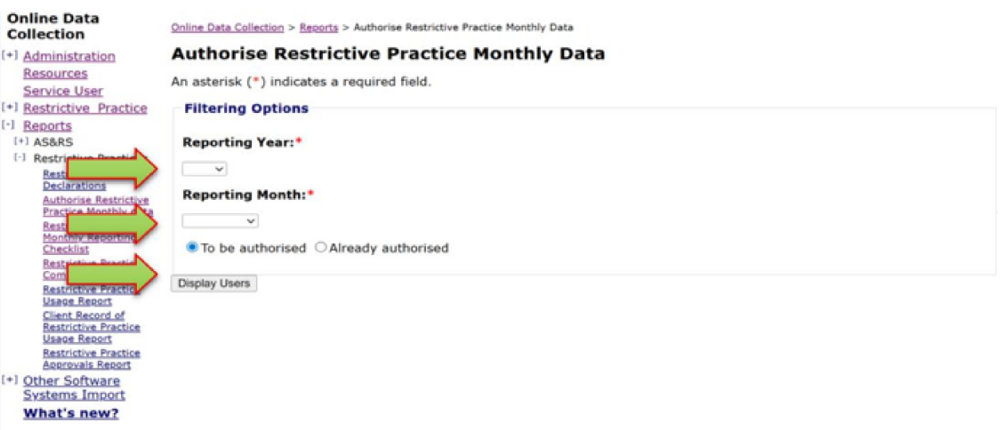
- Select ‘Display Service Users’ button to display the Authorise Restrictive Practice Monthly Data page with the Service User Restrictive Practice Details, see following result example.
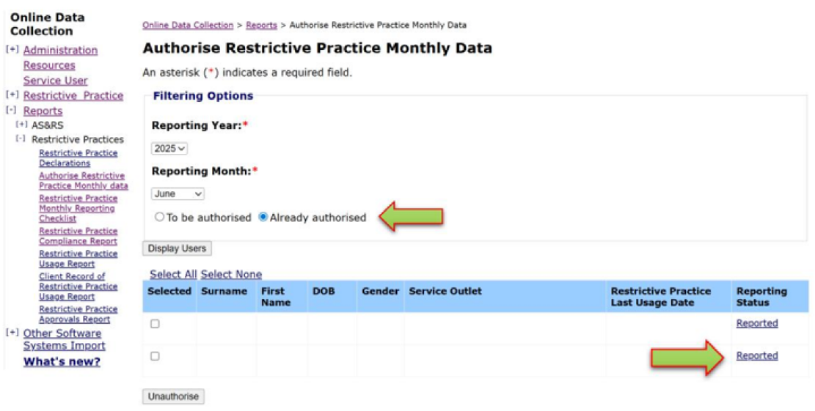

Reporting Status
On the Authorise Restrictive Practice Monthly Data page included in the Service User Restrictive Practice Details the result returned displays the following Reporting Status:

Reported
A Service User is determined as having a Reported status for the Service Outlet, Reporting Year and Month where:
- The Service User has been previously Authorised for the Service Outlet, Reporting Year and Reporting Month.

Service User’s Restrictive Practice Information to be Unauthorised
- Select individual Service Users by ticking the checkbox beside the Service User’s surname. (Unselect Service Users by ticking the checkbox to remove the tick.)
- Select the ‘Unauthorise’ button.
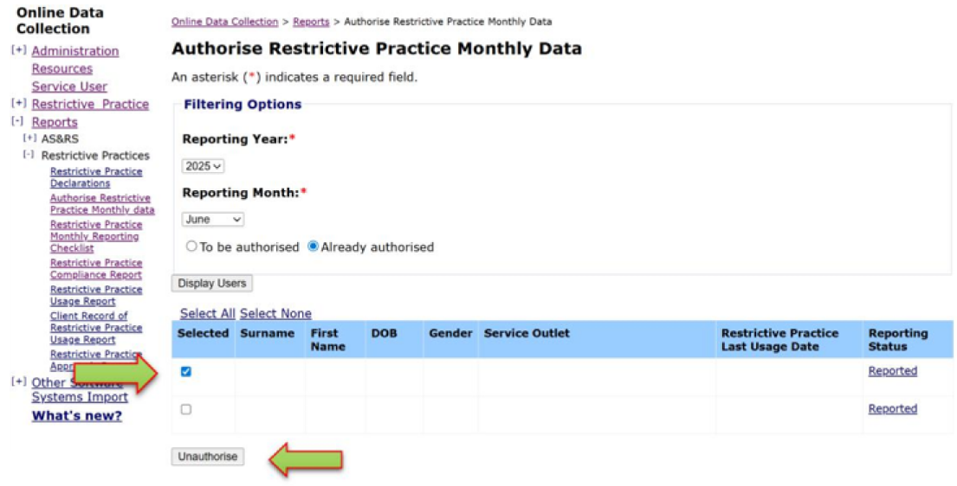
Tip:
- Use the Select All hyperlink to select all Service Users listed under the Service User Restrictive Practice Details in one step.
- Use the Select None hyperlink to deselect all selected Service Users listed under the Service User Restrictive Practice Details in one step.
- Selecting the Reported hyperlink will display the Restrictive Practice Summary screen for the selected Service User and Service Outlet.
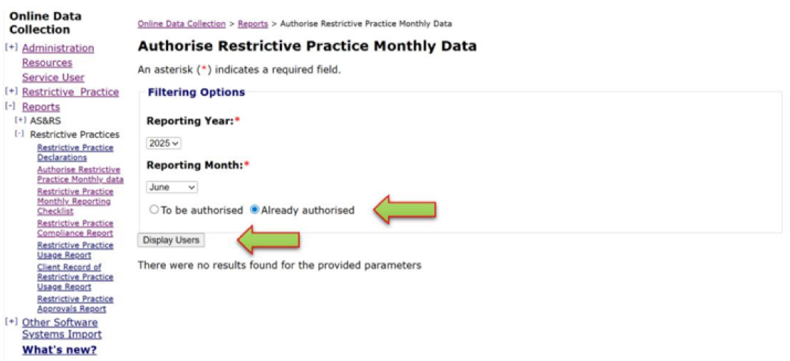
Where a Reporting Year, Month, Already authorised have been selected and the ‘Display Users’ button returns ‘There were no results found for the provided parameters’, there are no approved Service Users that match the Filtering Options.
Once unauthorised, and any changes made, the record must once again be authorised. This effectively locks the record from any further changes, unless the record is unauthorised.

